Splitting Process Development Manual
Last update: 2012-10-15
Daojun Cui
This document is the entry point of all documentation about the projects developed within the diploma thesis “Splitting BPEL Processes”.
It includes :
- Project specification
- Description and analysis of algorithms
- Development decision
- Details in code and underlying libraries
- Information of the references
The part concerning the BPEL4Chor data model and the project setup itself is provided in the documentation of the BPEL4Chor-model project.

This documentation is also covered by the Apache 2.0 license.

Table of Contents
1 Splitting BPEL Process 4
1.1 Project Specification 4
1.2 General Assumption 6
1.2.1 Configuration of The Main Process 6
1.3 Overview of Splitting Process Module 8
1.4 Command-line and Main Program 9
1.5 Partition Specification 10
1.5.1 Defining a Partition from Khalaf 10
1.5.2 Reference Implementation for Participant from Javier 10
1.5.3 Design for Partition Specification 10
1.5.4 Reader and Writer 12
1.6 Fragmenting Process 15
1.6.1 Artifacts for Communication between Client and the Fragment Processes 15
1.6.2 Creating Fragment WSDL Definitions 15
1.6.3 Concept of Copying the Original WSDL Definition Artifacts 17
1.6.4 Creating the Fragment Processes 18
1.6.5 Implementation for BPEL-D from Javier 20
1.6.6 Activity Diagram for Process Fragmentation 21
1.6.7 How the Links are handled 24
1.6.8 Some Details of the Code 25
1.6.9 Results of the Process Fragmentation 28
1.7 Fragmenting Control Dependency 29
1.7.1 Splitting Control Link 29
1.7.2 Is Link Cross Participants 31
1.7.3 Message for Control Link and Correlation 32
1.7.4 Creating Sending Block and Receiving Block 34
1.7.5 Setup the transitionCondition for 'Receive' in Receiving Block 37
1.7.6 Collect MessageLink Information for BPEL4Chor 37
1.7.7 Results of Control Link Fragmentation 37
1.8 Fragmenting Data Dependencies 37
1.8.1 High Level Logic for Fragmenting Data Dependencies 38
1.8.2 Data Flow Analysis and Qs(a, x) 38
1.8.3 Graph Modeling 39
1.8.4 Writer Dependency Graph (WDG) 40
1.8.5 Partitioned Writer Dependency Graph (PWDG) 41
1.8.6 PartnerLink Specification for Invoking- and Invoked-Partition 46
1.8.7 Message Specification for Invoke in LR and Receive in RF 47
1.8.8 Variable Initialization respecting the preset message specification 48
1.8.9 Creating prerequisites of LR and RF 48
1.8.10 Creating Local Resolver 50
1.8.11 Creating Receiving Flow 57
1.9 Output of BPEL4Chor Artifacts 59
1.9.1 Collecting BPEL4Chor Artifacts 59
1.9.2 Writing Out BPEL4Chor Artifacts 62
1.9.3 Compressing output files into one zip file 62
1.9.4 Decompressing the zip file 62
1.10 Correlation Set 63
1.10.1 Specification of Correlation Set 63
1.10.2 Handling Correlation Set in Process Fragmentation 64
1.10.3 Handling Correlation Set in Control Link Fragmentation 65
1.10.4 Handling Correlation Set in Data Dependency Fragmentation 66
1.10.5 Places Related To The Correlation Set 67
1.11 Project Metrics 68
2 Splitting Process Test 69
2.1 Project Specification 69
2.2 BPEL Projects for Testing 69
2.2.1 Prerequisites for Opening the BPEL Projects 69
2.2.2 Correlation Set in The Test BPEL process 69
2.2.3 Test Partition Specification 69
2.3 Project Metrics 70

Splitting BPEL Process

Project Specification
Project Parameter | Description
Project name | org.bpel4chor.splitProcess
Project type | eclipse plug-in
Input | (1)BPEL file  (2)WSDL definition  (3)Partition file
Output | (1)BPEL4Chor artifacts including PBDs, Topology and Grounding will be created and placed into the output directory, if not present, the default output directory will be used. The default output directory is c:\tmp\bpel4chor, if it does not exist, will automatically be created.  (2)All the files under that new directory will be added into a zip file, the zip file is placed in the same parent directory, if its name is not customized, the default name will be used. Default name for zip file is ProcessName+Choreography+TimeInMilliseconds.zip
Command-line | splitProcess -bpel FILE_PATH -partition FILE_PATH -output DIR_PATH  -bpel and -partition are mandatory. -output is optional.  If the argument -output is absent, the DEFAULT_SPLITTING_OUTPUT_DIR for output in BPEL4ChorConstants.java will be taken.
Description | This project accepts the bpel file and the partition file as input. It will split the BPEL process upon the given partition specification and transforms the process fragments into BPEL processes, whereas the information for BPEL4Chor choreography will be collected. At the end the BPEL processes will be exported as participant behavior description(PBD). Simultaneously the topology and grounding for BPEL4Chor will also be created and exported.
Initial packages | (1)cli  (2)dataflowanalysis  (3)exceptions  (4)fragmentation  (5)partition  (6)pwdg  (7)utils
Ref. libraries | (1)args4j - for command-line  (2)jgrapht - for graph representation of PWDG  (3)log4j - for logging
Ref. projects | (1)org.bpel4chor.model  (2)de.uni-stuttgart.iaas.bpel-d.algorithmus  (3)org.eclipse.bpel.model  (4)org.eclipse.emf.common  (5)org.eclipse.emf.ecore  (6)javax.wsdl  (7)org.eclipse.wst.wsdl  (8)org.eclipse.emf.ecore.xmi  (9)org.eclipse.xsd

General Assumption
- Only one single global CorrelationSet with a property of type xsd:string is used
- Designer assigns only basic activity into participant
- Sequence is not supported
- No Link comes in or from the structured activity, i.e. link can only combine to the begin or end of the activity.
- Basic Activity: Invoke, Receive, Reply, Assign, Throw, Rethrow, Wait, Exit, Empty, ExtensionActivity.
- Structured Activity: Flow, Scope, While, Sequence, ForEach, Pick, RepeatUntil
- Only global BPEL variable is declared
- BPEL Variable is always of message type, and the message consists of one or more parts, that are of simple type.
Note: The 4th point is an umbrella assumption so that the links in PWDG can correctly work even in the presence of loop and scope.

Configuration of The Main Process

Variable and Message
As mentioned in the previous section, we use only variables that are globally declared in the main BPEL process. And the BPEL variables are of message Type.
The message declaration in the WSDL must look like followings:
Message consists of one or more parts that are of simple type
<message name="OrderRequestMessage">
<part name="acountNumber" type="xsd:string"/>
<part name="status" type="xsd:string"/>
<part name="orderTotalPrice" type="xsd:int"/>
<part name="numDeliveries" type="xsd:int"/>
<part name="correlation" type="xsd:string"/><!-- This part is for correlation -->
</message>

And must NOT looks like the followings:
Anti-Example of the Message
<types>
...
<element name="OrderInfo">
<complexType>
<sequence>
<element name="acountNumber" type="string" />
<element name="oderStatus" type="string" />
<element name="orderTotalPrice" type="int" />
<element name="status" type="string" />
<element name="numDeliveries" type="int" />
<element name="correlation" type="xsd:string"/>
</sequence>
</complexType>
</element>
</types>
<message name="OrderRequestMessage">
<part element="tns:OrderInfo" name="payload" />
</message>

The message part with an element instead of simple type, can not be consumed by the algorithms in the paper of Khalaf (Maintaining Data Dependency Across BPEL Process Fragments).
For the data dependencies fragmentation we need direct access to the individual parts of the variable, which is of message type and whose parts are of simple type. Consider we have a variable 'orderInfo' of message type “OrderRequestMessage”, then we need to access the “acountNumber” by using “oderInfo.accountNumber”, NOT by “oderInfo.payload.accountNumber”.
The limitation for now:
- Variable can also be xsd simple type, but can NOT be complex xsd element type.
- Message can NOT use the 'part' that is defined as complex xsd element type.

Correlation Set
As mentioned, only one single correlation set will be used both in the main BPEL process and in the fragment processes.
Specification of the used correlation set in BPEL
<bpel:correlationSets>
<bpel:correlationSet name="CorrelationSet" properties="tns:correlProperty"/>
</bpel:correlationSets>

<!-- The correlation is initiated by the starting receive activity -->
<bpel:receive name="A" partnerLink="client"
operation="initiate" portType="tns:OrderingProcessPT"
createInstance="yes" variable="input">
<bpel:sources>
<bpel:source linkName="linkA2B"></bpel:source>
</bpel:sources>
<bpel:correlations>
<bpel:correlation set="CorrelationSet" initiate="yes"></bpel:correlation>
</bpel:correlations>
</bpel:receive>

Specification of the used correlation set in WSDL
<vprop:property name="correlProperty" type="xsd:string" />
<vprop:propertyAlias propertyName="tns:correlProperty"
messageType="tns:OrderRequest" part="correlation" />

Activity Limitation
For now only basic activities and one structured <flow> activity are used for the main process.

Overview of Splitting Process Module
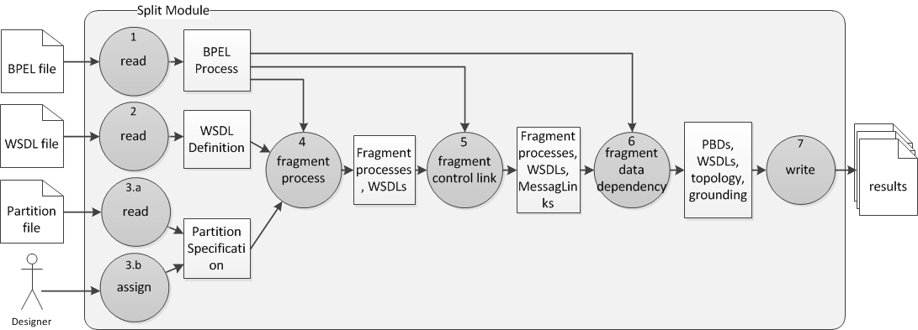

The following will give some description of the split module in the overview:
- BPELReader loads the BPEL file and creates a BPEL process
- BPEL4ChorReader loads the WSDL file and creates a WSDL definition
- PartitionSpecReader reads the partition file and creates a PartitionSpecification.
- ProcessFragmenter takes all the input data and fragment the main process into smaller fragment processes
- ControlLinkFragmenter takes the output of ProcessFragmenter and split the control link that crosses over processes by generating sending block and receiving block for each split link.
- DataDependencyFragmenter takes the output of ControlLinkFragmenter and split the data dependencies by generating local resolvers and receiving flow.
- BPEL4ChorWriter writes out the results in files.

Command-line and Main Program

Args4j is used, which is a simple to use java library, to take care of the input of the command-line.

The arguments for command-line:
java org.bpel4chor.splitProcess.cli.SplitProcessMainCmd -bpelfile FILE_PATH -partitionfile FILE_PATH -outputdir DIR_PATH

Class Diagram for the command-line:
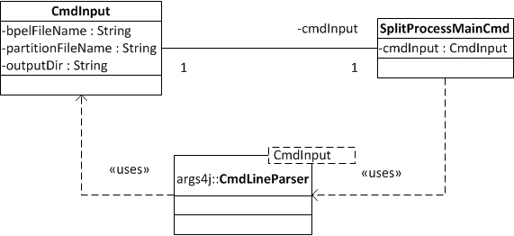

As showed in the class diagram, the command-line arguments are parsed by the “CmdLineParser” and they are set into the members of the “CmdInput”. After that we can e.g. use cmdInput.getBpelFileName() to get the argument “bpelFileName”.

Partition Specification

Defining a Partition from Khalaf
As introduced in Khalaf's dissertation a designer fragments a process by defining a partition specification, which contains one or more partitions that is set of all primitive activities in the process.
Definition of a Partition:
Consider Sn as a set of participant names. Every Participant p belongs to the set of participants.
Pa is the tuple set of participant name() and one or more activities(A).
Some restrictions:
- A participant must have at least one activity
- No two participants share a (primitive) activity or a name
- Every primitive activity of the process is assigned to a participant
Note: Scopes and loops are split by assigning the activities in them to different participant. The designer does not place the scope or loop itself in a participant. Only simple activity get to be assigned in participant.

Reference Implementation for Participant from Javier
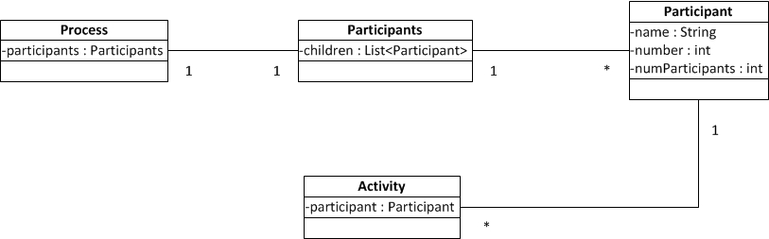
In Javier's Model the process, activity are bound with participants and participant, which makes the modification in BPEL model inevitable. Details see also in Diplomarbeit(Nr. 2616) of Javier Vazquez Fernandez

Design for Partition Specification

Requirements Analysis
Partition Specification should provide information about which activity is assigned to which participant.
We can either provide the information via a xml file, i.e. Partiton.xml, or directly assign the basic activity in BPEL designer and create a PartitionSpecification.

General requirements
- no modification to the BPEL model
- extensible for reemerging afterward[Discussion is needed]
- the restrictions for partition must be verified

Input from xml file
- Used Terms in Partition Specification
  - PartitionSpecification[vs. “Participants”, As the root definition for partition specification, “PartitionSpecification” is better.]
  - Participant[vs. “Partition”, participant indicates a fragment of the split processes, partition is ambiguous, it has 2 meanings, (1) The act or processing of dividing the main process into parts (2) The part or section into which the main process has been divided. As another reason to choose the term “Participant” is that it is used in Khalaf's Dissertation, and “Partition” is used as the act to divide the main process. So for consistency we will be using “Participant” here.]
  - Activity[“Activity” is here xPath to locate the real BPEL activity, it just provides the path for looking up the activity in the BPEL process, it has no need to exist in memory.]
- Partition Specification Syntax
Source: https://svn.flupp.de/BPEL-D/code/splitting/trunk/src/org.bpel4chor.splitProcess/src/resources/PartitionSpecSchema/partition.syntax
<partitionSpecification>
<participant name="NCName">+
<activity path="NCName"/>+
<!-- the String of path is xPath -->
</participant>
</partitionSpecification>

Input from GUI
The other input option is using GUI, we assign the activity in the bpel designer to a specific participant. In that case we get the activities directly from the BPEL process.

Class Diagram
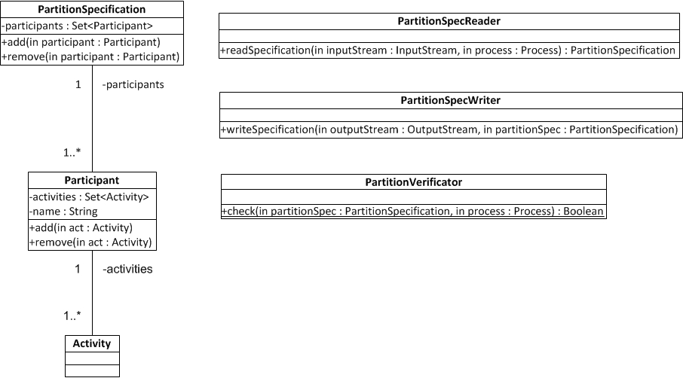

Reader and Writer

Decision for XML library
Library | Reader/Writer | Print in Pretty Format | Namespace aware? | Use? | Reason
StAX | XMLStreamReader/Writer | No | No | No | No pretty format print feature
JAXB | Unmarshaller/Marshaller | Yes | Yes | No | We do not need a representation of activity path in the memory
DOM | DOMParser/XMLSerializer | Yes | No | Yes | Namespace awareness is not our concern here. So it does not matter if DOM is not aware of Namespace. The point is that the Syntax of partition is simple enough to use DOM.

Specification of Reader
Category | Specification
Input | InputStream of Partition.xml, Process
Ouput | PartitionSpecification
Prerequisite: The corresponding BPEL process is loaded.

Specification of Writer
Category | Specification
Input | OutputStream of Partition.xml, PartitionSpecification
Output | Partition.xml

XPath to BPEL Activity
The main task of PartitionSpecUtil is to get a BPEL Activity from a input XPath. It generally will take 2 steps. First XPath -> XML Element, and second XML Element -> BPEL Activity.
2 Steps to convert the Xpath to BPEL activity
1. XPath -> xml element
BPELReader r;

private final XPathFactory factory;
private final XPath xpath;

this.factory = XPathFactory.newInstance();
this.xpath = factory.newXPath();
this.xpath.setNamespaceContext(new BPELnamespaceContext(r));

private Element getElement(String XPath) {
org.w3c.dom.Node res;
try {
res = (org.w3c.dom.Node) xpath.evaluate(XPath, r.getProcess().getElement(), XPathConstants.NODE);
} catch (XPathExpressionException e) {
e.printStackTrace();
return null;
}
return (Element) res;
}

The class for BPELnamespaceContext with a little justification

import java.util.Iterator;
import javax.xml.namespace.NamespaceContext;
import org.eclipse.bpel.model.Process;

public class BPELnamespaceContext implements NamespaceContext {

private String BPELNS;
private BPELnamespaceContext() {}

public BPELnamespaceContext(Process process) {
BPELNS = process.getElement().getNamespaceURI();
}

@Override
public String getNamespaceURI(String prefix) {
if (prefix.equalsIgnoreCase("bpel"))
return BPELNS;
else
return null;
}

@Override
public String getPrefix(String namespaceURI) {
throw new IllegalStateException();
}

@Override
public Iterator getPrefixes(String namespaceURI) {
throw new IllegalStateException();
}
}
2. xml element -> activity
Match found if: (getElement(xpath) == activity.getElement())

There are 2 possible implementation:

1) maintain a element2ActivityMap as the BPEL4ChorReader is reading in the BPEL file. Pro: it will be once and for all Con: It makes the BPEL4ChorReader more complex, the code will not be clean.

2) create a utility-class ActivityFinder(Process), and provide a find(element): Activity – Method. It iterates through the whole process-tree and test whether the element that the current activity holds is the same as the given one. Pro: straightforward, safe. Con: a little tricky to iterate and for each activity there must be one iteration. Possible Optimization: also maintain a element2ActivityMap, every un-touched element:activity pair will be collected along with the searching.

The end implementation applies the idea in 2).

Fragmenting Process
The process will be fragmented before the sucsessive steps begin, as shown in diagram of the Ch. 3.2(Split process details).
The outcome of fragmenting process is that for each participant there will be
- a BPEL process
- a WSDL definition.

Artifacts for Communication between Client and the Fragment Processes
Recall that for each fragment process a WSDL definition for that is also created. At the initial time we should collect the partnerlink from the non-split-process into the fragment process, when the partnerLink is referred by <invoke>, <receive>, and <reply> activities in the fragment.
Note:
- PartnerLink, PartnerLinkType, Role, PortType, Operation, Message, Part all exist in the beginning time as Proxy. Because all the stuffs come from WSDL world NOT BPEL world. In order to get full access of both the BPEL artifacts, WSDL artifacts, and even the external XSD artifacts, we must initialize the bpelPlugin as follows.
// init eclipse plugin
bpelPlugin = new BPELPlugin();
Resource.Factory.Registry.INSTANCE.getExtensionToFactoryMap().put("bpel",
new BPELResourceFactoryImpl());
Resource.Factory.Registry.INSTANCE.getExtensionToFactoryMap().put("wsdl",
new WSDLResourceFactoryImpl());
Resource.Factory.Registry.INSTANCE.getExtensionToFactoryMap().put("xsd",
new XSDResourceFactoryImpl());
This way, as the eclipse BPELReader is reading the BPEL process file, the WSDL imports will automatically be resolved by the WSDLReader. Then, we can get the information (portType, operation, message) we want without diving into WSDL.
- A property named “correlProperty” and an associated propertyAlias will be defined for each WSDL definition.

To allow creation and manipulation of WSDL Definition we will be using WSDL4J lib. It is already part of the JDK.
The interfaces is in javax.wsdl.*, and the implementation is in com.ibm.wsdl.*.

Some utility classes in BPEL model should be noticed, e.g. org.eclipse.bpel.model.util.WSDLUtil.java.

Creating Fragment WSDL Definitions
As we are fragmenting the non-split process, we also copy the partnerLinks and variables that are used in the fragment into the fragment process. While copying the partnerLinks, we must also copy the partnerLinkType, portType, and operation into the fragment process's WSDL definition. While copying the variable, we must also copy the messageType , which is referred by the variable, in to the fragment process's WSDL definition. The artifacts from the original WSDL definition must be fully copied, any direct references to the original WSDL in the fragment WSDL definition will cause the following exception:
org.w3c.dom.DOMException: WRONG_DOCUMENT_ERR: A node is used in a different document than the one that created it.

Concept of Copying the Original WSDL Definition Artifacts
For any WSDL artifact that is referred by the fragment process, we have to copy the corresponding WSDL artifacts from the original WSDL definition
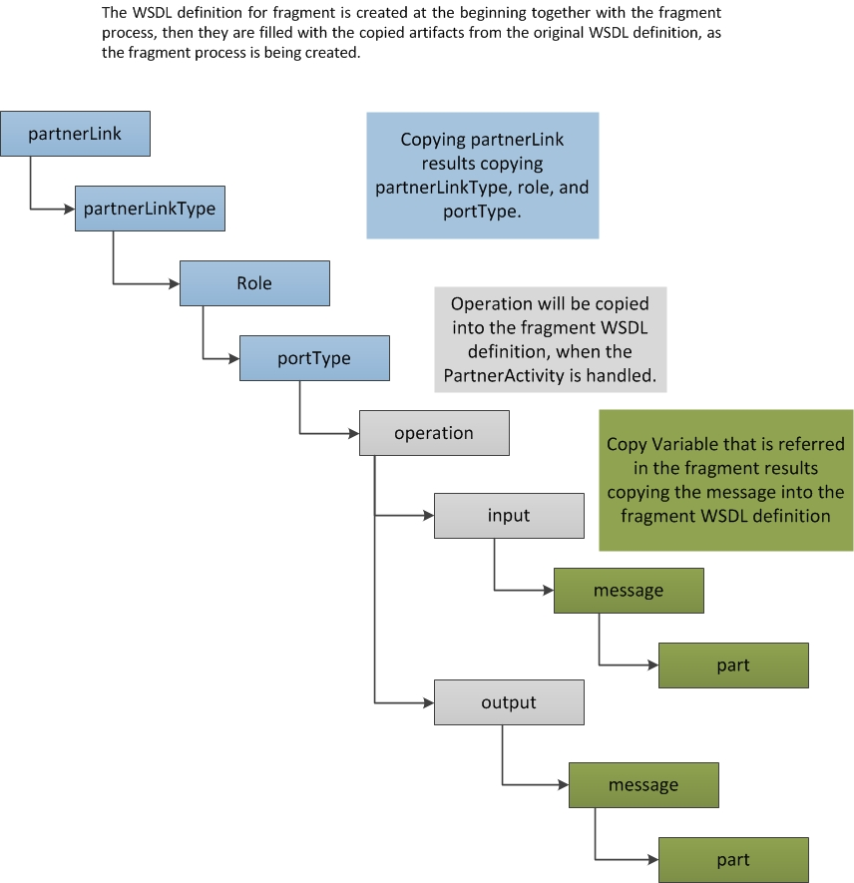

Creating the Fragment Processes
Two functions are provided in the Khalaf's Dissertation for creating the Process Fragments.
Source:Dissertation of R. Khalaf, Chapter 5.7.2, Creating Process Fragments
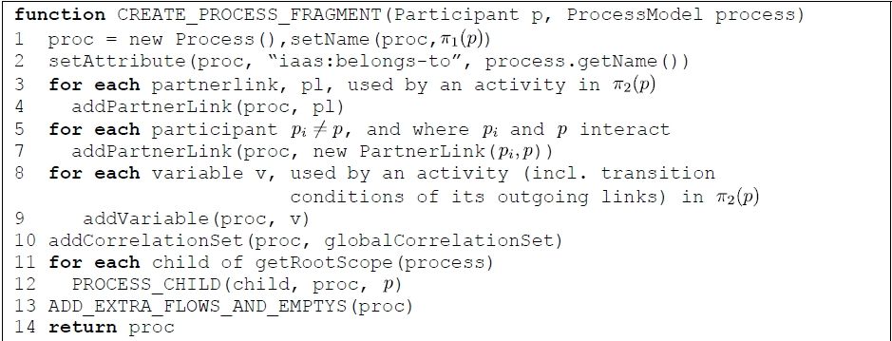
The Participant p will be interpreted as a partition, it looks like p₁=(n₁, {A, B, C}), n₁ is the partition name, A,B, C are activities. The π₁(p) =n₁, and π₂(p)={A, B, C}.
Note:
In line 11, getRootsScope(process) = process himself. So child of getRootScope(process) is the process.getActivity(). Then in line 12, the first input of process_child(child, proc, p), should be child=process.getActivity, proc=new Process(), p=participant.

Before we recursively copy the activities that are used in the fragment into its fragment process, we copy all the variables (including message), the parnterLink (incldung partnerLinkType, role, portType, and operation).

Add Variable
For preparation of copying activities into the target fragment process, we collect all the variables that are referred by the activities in the fragment, e.g. <assign>, <invoke>, <receive>, <reply>.
For each variable that is referred in the fragment, if the message type of the variable can be found in the non-split-process wsdl definition, then we make a copy of it and insert the copy into the fragment wsdl definition.
If the message is not defined in the non-split wsdl definition, then we simply make a copy and set to the new created variable in the fragment process.
For more information, see also org.bpel4chor.splitprocess.fragmentation.ProcessFragmenter.addVariable(Process, Participant)

Add PartnerLink
After the Variables being added into the fragment process and the corresponding messages being added into the fragment wsdl definition, the partnerLinks should be added into the fragment process.
For adding partnerLink, we iterate through all the activities that are assigned in the participant, in case the activity implement the interface PartnerActivity then it will refers a partnerLink. Normally, a PartnerActivity is a communication activity, e.g. <invoke>, <receive>, <reply>. Since the parnterLink has the following structure.
ParnterLink (presents in BPEL)
→ partnerLinktype (presents in WSDL)
→ role (presents in WSDL)
→ portType (presents in WSDL)
→ operation (presents in WSDL)
As we are copying the parnterLink, the sub-structures are correspondingly also copied and added into the WSDL definition.
If the partnerLinkType, which is referred by the partnerLink, is found in the non-split WSDL definition, then we make a copy and insert it into the fragment's WSDL definition, otherwise, just make a copy and set it to the new created partnerLink.
For more information, see org.bpel4chor.splitprocess.fragmentation.ProcessFragmenter.addPartnerLink(Process, Participant)

Process Child
Source:Dissertation of R. Khalaf, Chapter 5.7.2, PROCESS_CHILD
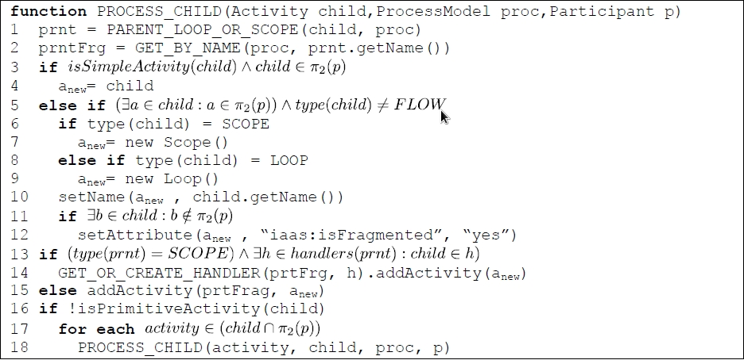
Note:
- PROCESS_CHILD function determines for each child activity whether and how to map it to the target fragment's process.
- PARENT_LOOP_OR_SCOPE function finds the child's first loop or scope parent in the UNSPLIT PROCESS.(line 1)
- GET_BY_NAME function takes an activity from the UNSPLIT PROCESS and returns the equivalent activity in
the fragment’s process if any is found.
- isSimpleActivity function tells whether an activity is simple. (INVOKE, RECEIVE, REPLY, ASSIGN, FLOW)
- isPrimitiveActivity function tells whether an activity is primitive. ( INVOKE, RECEIVE, REPLY, ASSIGN)
- GET_OR_CREATE_HANDLER function create an handler or get an handler
- The Idea behind PROCESS_CHILD: If the child is in or has activities that are in the fragment, then it must be placed in that fragment’s process - more specifically, we find the place for this child, firstly, the child' first parent loop or scope in the unsplit process(PARENT_LOOP_OR_SCOPE), and then get the equivalent one in the fragment process(GET_BY_NAME).
- The BPEL model does not have a back tracking mechanism from child to parent, so a Utility Class ActivityFinder will be created for this Job. This Util is also used in the Partition package. It is now in the package org.bpel4chor.splitprocess.utils.

Implementation for BPEL-D from Javier
The following is a little research on the Javier's code. The purpose is to see whether we can harvest the part on fragmenting process from his code base.
// org.eclipse.bpel.ui.util.BPELProcessSplitter
public boolean splitProcess(){

try {
System.out.println("BPELProcessSplitter - splitProcess");

if(testConditions()){

fragments = createFragments();
fragments = addCorrelations(fragments, correlationSets);
fragments = setActivities(activityList, fragments);
fragments = addPartnerLinks(fragments, partnerLinks);

splitProcessControlLinks();
splitProcessDataLinks();

//restoreAssigns();

writeFragments();
}
else{
System.out.println("---------- Please test the situation and try again ----------");
}
} catch (Exception e) {
e.printStackTrace(System.err);
}
return true;
}
/** Identify and create each fragment of the process */
protected List createFragments(){
crate a new process for each participant
}
/** Add copy of the correlation sets */
protected List addCorrelations(List processes, CorrelationSets correlationSets){
copy correlations from the original process into the fragments
}
/** Place the activities in the different fragments */
protected List setActivities(List activityList, List processes) {
create a new Flow as root activity for each fragment-process;
copy activity into fragment-process respectively;
}
/** Add copies of partner links used by the fragment */
protected List addPartnerLinks(List processes, PartnerLinks partnerLinks){
iterate in each activity in each fragment-process,
if(activity refer to a partnerlink) add to fragment-process;
}
protected void splitProcessControlLinks(){
for each activity in each fragment-process do
if the activity contains sources of links
for each link do
if the link crossed the boundary
split the link with (createSendingBlock, createReceivingBlock);
else
add link into flow of current fragment-process;
fi
od
fi
od

}

This implementation is based on the modification in the BPEL Activity. Each Activity in BPEL process is assigned to a participant by designer. One can use activity.getParticipant() to get the information that to which partition the activity belongs. This mechanism will influence the implementation of the creating process fragment.
Conclusion:
- The implementation of Javier did not follow the algorithms from Khalaf very strictly.
- The Part for Cross Participant Scope is not implemented.
- The Part for WSDL definition creation is also absent.

Activity Diagram for Process Fragmentation
My implementation will be following the algorithms of Khalaf's dessertation(chapter 5.7), and copying some util-methods from Javier, his logic for process fragmentation is not useable, because it was supposed to used for BPEL-D.

Activity Diagram – fragmentizeProcess
Fragmentize the main process
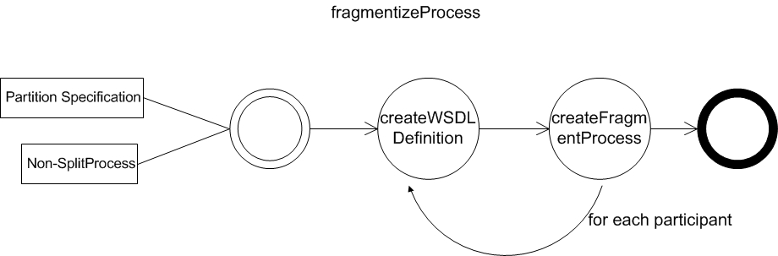

Activity Diagram – createFragmentProcess
Create Fragment Process
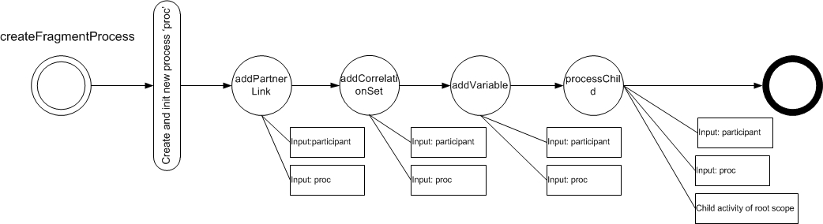

Activity Diagram – processChild
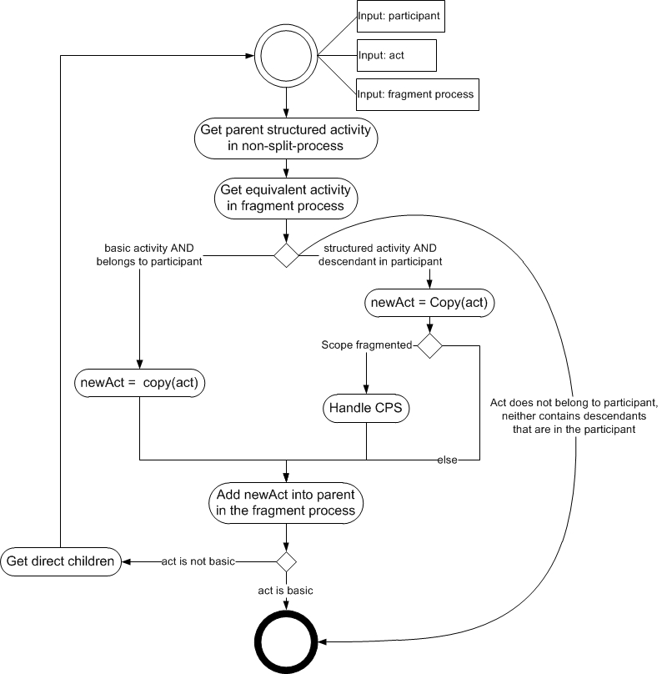

Class Diagram for Process Fragmentation
ProcessFragmenter depends on RuntimeData, uses FragmentDuplicator, FragmentFactory, ActivityFinder, and PartitionSpecification
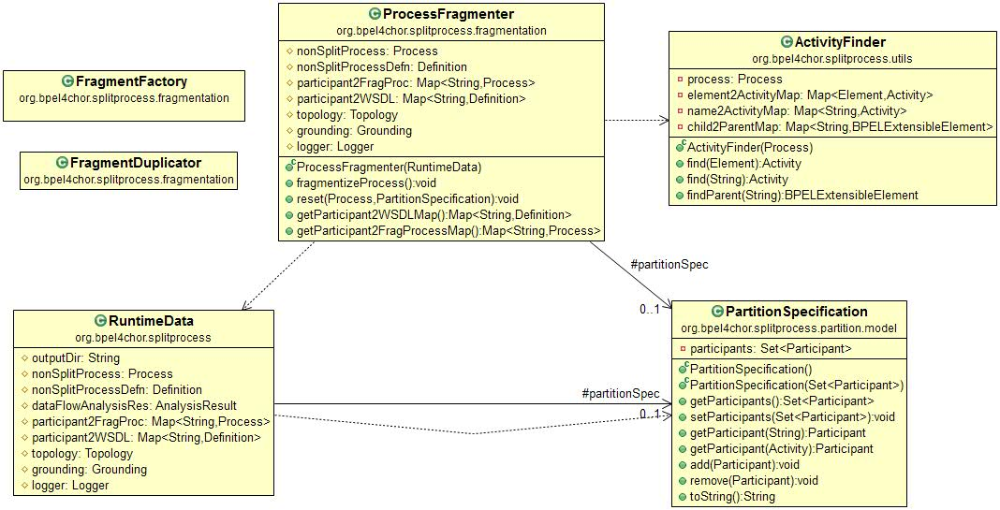

How the Links are handled
The links will be copied into the activity's source and target. After the process fragmentation there will be two copies of the link.
Snapshot after the process fragmentation
With the partition p2={p_{x},p_{y}}, p_{x}=(x,{a}), p_{y}=(y,{b, c})
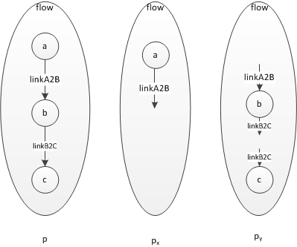

Some Details of the Code

Namespace of the fragment processes and WSDL definitions
The targetNamespace of the fragment process and WSDL definition will inherit the same targetNamespace from the process and WSDL.

Directly used code from Javier
Most of the copyXXX-methods in class BPELProcessSplitter are adapted

Code Structure for process fragmentation
The main structure of process fragmentation in Khalaf's Dessertation(chapter 5.7) will be followed, but there is slightly different by naming terminlogy.
- PARENT_SCOPE_OR_LOOP => getParentStructuredAct
- GET_BY_NAME => getEquivalentAct

Extract variable from transmitCondition
Source:
Project de.uni-stuttgart.iaas.bpel-d.algorithmus:
-> de.uni_stuttgart.iaas.bpel_d.algorithm.analysis.Process.addExpressionToRes
private static void addExpressionToRes(String expression, Collection<String> res) {
// pattern for a variable in XPath (Quickhack. It would be better to have an XPath AST or similar)
Pattern pattern = Pattern.compile("\\$[0-9a-zA-Z_.]+");
Matcher matcher = pattern.matcher(expression);
while (matcher.find()) {
String var = expression.substring(matcher.start()+1, matcher.end());
res.add(var);
}
}

-> AST: org.jaxen

BPEL Model Proxy Mechanism
BPEL PartnerLink, PartnerLinkType, Variable, Link, Operation, Role, Port, PortType are all using the “Proxy”-pattern. It means, as the BPELReader are transforming the xml to BPEL element, what is done, is, that a Proxy for e.g. a PartnerLinkTypeProxy is created, NOT a real PartnerLinkType. All BPEL Proxy Object contain an BPELProxyURI, The PartnerLinkTypeProxy Object can be passed back to the PartnerLinkType, because it is extended from PartnerLinkType. The proxy describes only where the real variable is, by using a BPELProxyURI. So the real variable is only be retrieved, when one call the method like getMyRole() or getPartnerLinkType() in the PartnerLink Object.
Example Code in BPELReader:
The partnerLinkType, Role in PartnerLink are all proxy
org.eclipse.bpel.model.resource.BPELReader.xml2PartnerLink(Element):
--------------------------------------------------------------------
PartnerLinkTypeProxy slt = new PartnerLinkTypeProxy(getResource().getURI(), sltQName);
partnerLink.setPartnerLinkType(slt);
if(slt != null) {
partnerLink.setPartnerLinkType(slt);

if (partnerLinkElement.hasAttribute("myRole")) {
RoleProxy role = new RoleProxy(getResource(), slt, partnerLinkElement.getAttribute("myRole"));
partnerLink.setMyRole(role);
}
if (partnerLinkElement.hasAttribute("partnerRole")) {
RoleProxy role = new RoleProxy(getResource(), slt, partnerLinkElement.getAttribute("partnerRole"));
partnerLink.setPartnerRole(role);
}
}

The real call mechanism look like:
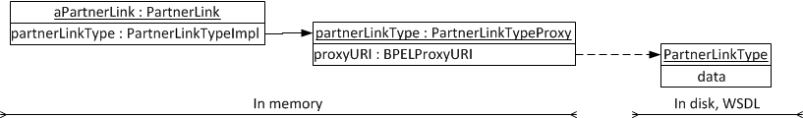

Behaviors by operation on Proxy members
Method | Behavor
Get-Method | eResolve(proxyObject)
Set-Method | oldContainer.eInverseRemove(newObject)  newContainer.eInverseAdd(newObject)

BPEL Activity and Artifacts E-Notification Mechanism
All activity or artifacts inherit BPEL ExtensibleElement, and BPEL ExtensibleElement inherit EObject from EMF. They all has the ability to inversely add or remove element from his parent. One must be very aware of the eNotification in the BPEL model, it can easily cause error, if your code does not concern about it.
An Example for eNotification looks like :
org.eclipse.bpel.model.impl.ProcessImpl.setVariables(Variables)
as one set a variables, it will call BasicEObject.eBasicRemoveFromContainer, which tries to remove the variables from its previous container at first, after it has no more association to other container, then, it can really be set to the variables reference of the caller, by InternalEObject.eInverseAdd(...).
public void setVariables(Variables newVariables) {
if (newVariables != variables) {
NotificationChain msgs = null;
if (variables != null)
msgs = ((InternalEObject) variables)
.eInverseRemove(this, EOPPOSITE_FEATURE_BASE
- BPELPackage.PROCESS__VARIABLES, null, msgs);
if (newVariables != null)
msgs = ((InternalEObject) newVariables)
.eInverseAdd(this, EOPPOSITE_FEATURE_BASE
- BPELPackage.PROCESS__VARIABLES, null, msgs);
msgs = basicSetVariables(newVariables, msgs);
if (msgs != null)
msgs.dispatch();
} else if (eNotificationRequired())
eNotify(new ENotificationImpl(this, Notification.SET,
BPELPackage.PROCESS__VARIABLES, newVariables, newVariables));
}
}
A possible error scenario:

---------begin---------------
Process processA = null;
Process processB = null;
Variables variables = null;

processA = BPELFactory.eINSTANCE.createProcess();
processB = BPELFactory.eINSTANCE.createProcess();
variables = BPELFactory.eINSTANCE.createVariables();

// now the variables is in process A
processA.setVariables(variables);

// now the variables is in process B too
processB.setVariables(variables);

// lets try to get the variables from processA
processA.getVariables().getChildren();
---------end---------------
Now you get a NullPointerException! As we set the variables in the processB, it inversely removed the variables from the processA, and set the processA.variables to null, because, at that time, the eNotification triggered the eInverseRemove(...) of the super object , therefore, processA.getVariables()==null.

Conclusion is that
- One must be very careful while setting e.g. partnerLinkType into a partnerLink, it is not simple set operation, the partnerLinkType will be removed from its previous container at first, and then it can be added into the new container.
- The partnerLinkType, Operation etc. etc. are implicitly Proxy Type, that is given by the BPELReader, it only loads the read data once the get-Method is called.
- This mechanism intends to synchronize the BPEL model in GUI designer with the object of BPEL model. So there is always eInverseRemove() and eInverseAdd() in the BPEL element's setXXX(...) method.

Cross Partner Scope implementation
If a scope of the main process crosses multiple participants, then a cross participant scope will be created, the information, about which activity of the scope get assigned in which participant, should be collected and be stored into a BPEL4Chor ingredient file.

Results of the Process Fragmentation
- The non-split-process is fragmented into small processes.
- The CorrelationSet is copied
- The partnerLink is also copied
- The Variables are copied
- The activities that belong to each participant are copied.
  - But the links in the 'source' and 'target' of the activity have only copied the original link name, it hasn't copied the source/target that references the orignial link, neither it is added into the flow.
  - The links MUST be added into the holder flow latter, in case the source and target are in same partition, or MUST be split. And that is job of ControlLinkFragmenter
When the source and target reside in different partition ,the control link in the fragment process now looks like following figure:
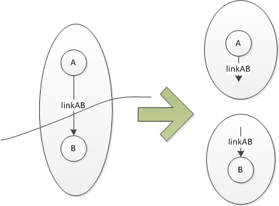

Fragmenting Control Dependency

Splitting Control Link
Splitting control link is also implemented by Javier, it is in the project https://svn.flupp.de/BPEL-D/code/BPEL-D_-_Modeller/trunk/src/org.eclipse.bpel.ui under org.eclipse.bpel.ui.util.BPELProcessSplitter.splitProcessControlLinks()
But its underlying partition information is embedded into the activity(NOT explicitly per partition file given by designer), which is different from ours, so his code is helpful but NOT directly usable for me.
Source: Concept in dessertation Khalaf, Chap 5.8, Figure 33
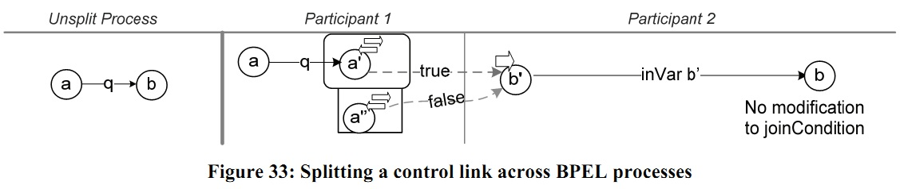
Things to create by splitting control link:
- message for true, false and correlation
- variable for invoke a' and a'' and receive b'
- Scope for a', and fault handler for a''
- Invoke a', a'' and receive b'
- Link (q, a, b) in source process, link (inVar, b', b) in target process
- Set SuppressJoinFailure in invoke a' to 'false'
- PartnerLink, PartnerLinkType, PortType, Operation

Is Link Cross Participants
How to tell whether a control link crosses over the participants(processes). The figure illustrates how to do it based on the results from our process fragmentation.
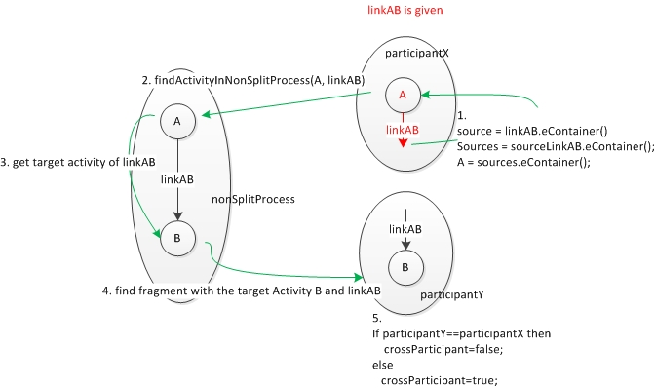

A simpler solution to tell whether a control link crosses over the participants.
This method is implemented!
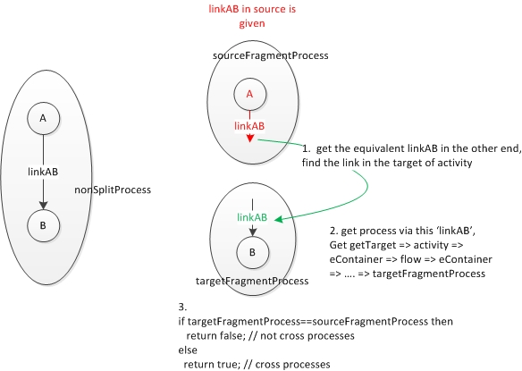
Code: org.bpel4chor.splitprocess.fragmentation.ControlLinkFragmenter.splitControlLink()
...
Process targetProcess = (targetProcess.equals(sourceProcess) ? false : true);
boolean linkCrossProcesses = targetProcess.equals(sourceProcess);
if (linkCrossProcesses) {// then split the link
…
}

Message for Control Link and Correlation
A control link message will be created in to the WSDL of the “invoked” fragment process. And the control message will contain two parts. A part is named “status” and is of type xsd:boolean, the other part is named “correlation” and is of type xsd:boolean. It will be responsible for conveying the control information.
Besides the control link message, the propertyAlias for correlation will be created in the WSDL as well.

Example of correlation set in BPEL-D and the propertyAlias in its WSDL
Source: https://svn.flupp.de/BPEL-D/code/BPEL-D_-_Modeller/trunk/samples/TwoAssigns/{TwoAssigns.bpel, echoDefs.wsdl}
CorrelationSet in BPEL | xmlns:ns1="http://activebpel.org/echoDefs"  <bpws:correlationSets>  <bpws:correlationSet name="name" properties="ns1:echo"/>  </bpws:correlationSets>
PropertyAlias in WSDL | <wsdl:definitions targetNamespace="http://activebpel.org/echoDefs"  ...>  <wsdl:message name="echoRequest">  <wsdl:part name="echoPart" type="xsd:string"/>  </wsdl:message>  <bpws:property name="echo" type="xsd:string"/>  <bpws:propertyAlias propertyName="tns:echo"  messageType="tns:echoRequest" part="echoPart"/>

Our Specification for the global Correlation Property
Artifacts | Specification
BPEL Process  Non-split | xmlns:ns1="http://www.bpel4chor.org/"  <bpws:correlationSets>  <bpws:correlationSet name="name" properties="ns1:correlProperty"/>  </bpws:correlationSets>
WSDL  Non-split-process | <wsdl:definitions targetNamespace="http://www.bpel4chor.org/fragments"  ...>  <bpws:property name="correlProperty" type="xsd:boolean"/>
BPEL Process  fragment participant | xmlns:ns1="http://www.bpel4chor.org/"  <bpws:correlationSets>  <bpws:correlationSet name="name" properties="ns1:correlProperty"/>  </bpws:correlationSets>
BPEL Process  fragment participant | This information is inserted to the fragment process when the process is initialized.  Code: org.bpel4chor.splitprocess.fragmentation.ProcessFragmenter.addCorrelations(Process)  addCorrelations() - ProcessFragmenter  <- createFragmentProcess() - ProcessFragmenter  <- fragmentizeProcess() - ProcessFragmenter
WSDL for Participants | <wsdl:definitions targetNamespace="http://www.bpel4chor.org/fragments"  ...>  <wsdl:message name="controlLinkMessage">  <wsdl:part name="status" type="xsd:boolean"/>  <wsdl:part name="correlation" type="xsd:boolean"/>  </wsdl:message>  <bpws:property name="correlProperty" type="xsd:boolean"/>  <bpws:propertyAlias propertyName="tns:correlProperty"  messageType="tns:controlLinkMessage" part="correlation"/>
WSDL for Participants | This information is inserted to the wsdl definition of the fragment process at the same time as it is created.  Code:  org.bpel4chor.splitprocess.fragmentation.FragmentFactory.createWSDLDefinition(Process)  createWSDLDefinition() - FragmentFactory  <- fragmentizeProcess() - ProcessFragmenter

Artifacts | Specification
Control Link Message | <wsdl:message name="controlLinkMessage">  <wsdl:part name="status" type="xsd:boolean"/>  <wsdl:part name="correlation" type="xsd:boolean"/>  </wsdl:message>

Creating Sending Block and Receiving Block

Prerequisites for sending- and receiving block
One might argue that why not create some artificial structures and just collect the information to construct message link in BPEL4Chor. Well, the participant behavior descriptions(PBDs) are in fact our split processes, only they are exported as abstract BPEL profile and include the 'wsu:id', therefore the structures must be real and correct, or it won't work when we do the re-generation of the processes and deploy them to work-flow engine.
Artifact | Referred In Source Process | Referred In Target Process | Containment
Control Link Message | Yes | Yes | The message to conveys control information  should be added to WSDL of process invoked
Variable for true and correlation | Yes | No | should be added to invoking process
Variable for false and correlation | Yes | No | should be added to invoking process
Variable for receive | No | Yes | should be added to process invoked
Operation | Yes | Yes | should be added to WSDL of process invoked
PortType | Yes | Yes | should be added to WSDL of process invoked
Role | Yes | Yes | should be added to WSDL of process invoked
PartnerLinkType | Yes | Yes | should be added to WSDL of process invoked
PartnerLink for invoking process | Yes | No | should be added to invoking process
PartnerLink for process invoked | No | Yes | should be added to process invoked
Code: org.bpel4chor.splitprocess.fragmentation.BlockBuilder.createPrerequisites()

Specification for the re-usable artifacts
Category | Name | Multiplicity
PartnerLink | invokingPartitionName  +invokedPartitionName  +'PL' | One for each pair of invoking- and invoked-partition
PartnerLinkType | invokingPartitionName  +invokedPartitionName  +'PLT' | One for each pair of invoking- and invoked-partition
Role | invokingPartitionName  +invokedPartitionName  +'ROLE' | One for each pair of invoking- and invoked-partition
PortType | invokingPartitionName  +invokedPartitionName  +'PT' | One for each pair of invoking- and invoked-partition
Note: Take the naming convention so that the partnerLink, partnerLinkType, and portType can be re-used in the next stage, fragmenting data dependencies.

Creating Sending Block and Receiving Block
Implementation: org.bpel4chor.splitprocess.fragmentation.BlockBuilder
Code:
org.bpel4chor.splitprocess.fragmentation.BlockBuilder.createSendingBlock()
org.bpel4chor.splitprocess.fragmentation.BlockBuilder.createReceivingBlock()
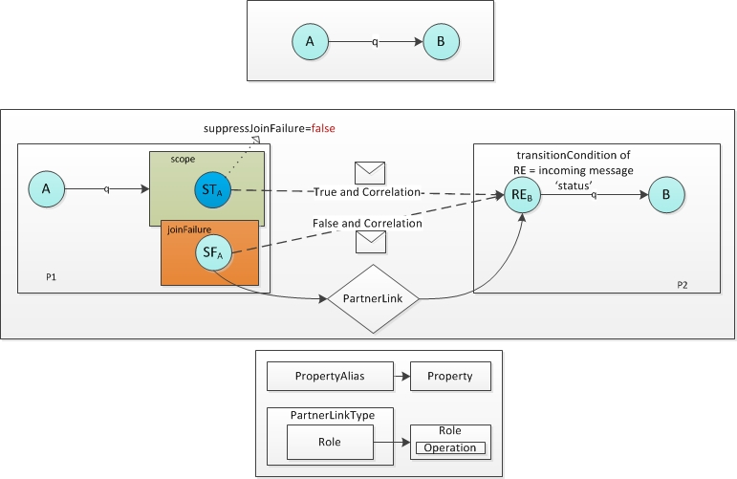
Note:
- P1, P2 are fragment processes
- ST_{A} and SF_{A} are invoke activities, RE_{B} is receive activity
- In ST_{A} is suppressJoinFailure=false
- joinCondition of ST_{A} = transitionCondition of link
- transitionCondition of A is untouched
- joinCondition of B is untouched
- The underlying PartnerLink, PartnerLinkType, Role etc are defined in the WSDL of the invoked process P2

Initializing the Variable for sending true or false and correlation
TODO
- initialization with proceeding assign in the sending block
- initialization with an assign after the beginning receive in the fragment process
- use in-line from-spec in the variable

Setup the transitionCondition for 'Receive' in Receiving Block
Code: org.bpel4chor.splitprocess.fragmentation.BlockBuilder.createReceivingBlock()
// setup transition condition
Condition condition = BPELFactory.eINSTANCE.createCondition();
condition.setExpressionLanguage("boolean($" + varReceive.getName() + ".status)");

Collect MessageLink Information for BPEL4Chor
The information for message link in BPEL4Chor should be collected as the sending block and receiving block are being created, and be stored in RuntimeData for the BPEL4Chor output.

Results of Control Link Fragmentation
The outcome of the fragmenting control dependency is :
- Sending block in the source process
  - 1 x Scope, 2 x Sequence, 1 x Fault Handler, 2 x Assigns, 2 x Invoke(one of them with suppressJoinFailure=true)
  - 1 x PartnerLink
- Receiving block in the target process
  - 1 x Receive, with createInstance=true
- Artifacts in the target WSDL definition
  - 1 x Message with 2 parts, a)status b)correlation, both are of type boolean.
  - 1 x PartnerLink
  - 1 x ParnterLinkType including Role, PortType, Operation, Message

Fragmenting Data Dependencies
For fragmenting data dependencies we got to do the following things
- Get Query-Writer-Set Q_{s}(a, x) from Data Flow Analysis
- Create Graph Model to represent WDG and PWDG
- Create WDG_{(a, x)} from Q_{s}(a, x)
- Create PWDG_{(a, x)} from WDG_{(a, x)}
- Create Local Resolver for each PWDG node
- Create Receiving Flow in the reader PWDG node

High Level Logic for Fragmenting Data Dependencies
Code: org.bpel4chor.splitprocess.fragmentation.DataDependencyFragmenter
- Given [p] as fragment process set
- Given [a] as activity set of non-split-process
- d ← Analyze(non-split-process)
- for each a in [a] do
for each variable x that a reads do
create Q_{s}(a, x) from d
create WDG_{(a,x)} from Q_{s}(a, x)
create PWDG_{(a,x)} from WDG_{(a,x)}
create Prerequisites(message, portType, partnerLink, etc.)
for each PWDG node n do
CREATE-LOCAL-RESOLVER-MULTIPLE-WRITERS (n, a, x)
end for
CREATE-RF(PWDG_{(a,x)})// in a's process p_{a}
end for
end for

All variables that activity reads(minimal set)
- Invoke, inputVariable, from-spec variable
- Assign, from-spec
- Reply, inputVariable
- Variables in all joinConditions and transitionConditions
Code Reference: org.bpel4chor.splitprocess.utils.VariableResolver.resolveReadVariable(Activity)

Data Flow Analysis and Q_{s}(a, x)

Data Flow Analysis
The results of the data flow analysis look like the following table, for reader a and variable x what we need is (a, x, IN, {w₁, w₂}⋃{w₃, w₄})
Activity | Variable | Query | Placement | Writes
 |  |  |  | poss | inv | mbd
a | x | .m | IN | {w₁, w₂}
a | x | .n | IN | {w₃, w₄}

Q_{s}(a, x) is a set of tuples each contains a query set and a writer set
We take the example above, Q_{s}(a, x) = { ({x.m}, {w₁, w₂}), ({x.n}, {w₃, w₄}) } , if we tranform them into tuples, it looks like { ({.m}, {w₁, w₂}), ({.n}, {w₃, w₄}) } , if the whole variable is queried, it is an empty string, {}.
Note:
- In the presence of Loops/Scope, the Q_{s}(a, x) must agree to some constraints. See also in the paper “Maintaining Data Dependencies Across BPEL Process Fragments” Chap. 5, Encode Dependencies. In the initial development, Loop/scope will be taken out for simplicity. They will be handled in the next stage of the development.

Representation of Q_{s}(a, x) in code
See: org.bpel4chor.splitprocess.dataflowanalysis.QueryWriterSet

Graph Modeling

Used graph library
- JgraphT v0.8.3

Requirements for our graphs
- Directed and acyclic graph
- Node(vertex) of the graph should be able to contain information, e.g. activity, partition
- Edge of the graph contains source and target
- Graph path, to tell whether a path crosses multiple partitions

Modeling the graph for WDG and PWDG
Category | Description
WDG | Directed acyclic graph(DAG), contains a set of nodes and a set of edges
WDGNode | Node of WDG, contains an activity
WDGEdge | DefaultEdge from JGraphT, contains a source WDGNode and a target one
PWDG | Directed acyclic graph(DAG), contains a set of nodes and a set of edges
PWDGNode | Node of PWDG, consists of a participant name and a set of WDG nodes
PWDGEdge | DefaultEdge from JGraphT, contains a source PWDGNode and a target one
Note:
- DAG = Directed Acyclic Graph
- WDG = Writer Dependency Graph, is of type DAG
- PWDG = Partitioned Writer Dependency Graph, is of type DAG
- Pros for this modeling
  - Clear Layering, BPEL Activity -> WDG Node -> PWDG Node, each layer is just dependent on its underlying layer. If we try to extend the WDG to support Loop or Scope by collapsing it as a WDG node, it does not affect PWDG. For PWDG it operates the same way as before.
- Cons for this modeling
  - Before we get to create Local Resolver and Receiving follow, there is a long way to go: Data Flow Analysis -> Q_{s}(a, x) -> Writer Set -> WDG -> plus Partition Specification -> PWDG -> Local Resolver and Receiving Flow.
- If you directly make Activity as WDG node, it will mess up with you as you are trying to construct the WDG and PWDG. In both WDG and PWDG we need to create the Nodes and Edges out of the underlying Layer, if they both are relying on BPEL activity, then whether the navigation is on the BPEL links or on the WDG edges must be very carefully distinguished. Which makes the job difficult to be done.

Class Diagram
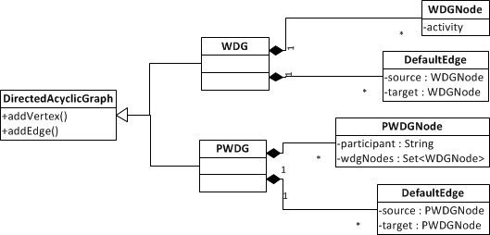

Writer Dependency Graph (WDG)

Specification of WDG
- WDG_{(a, x)} = (V_{d}, E_{d}), V_{d}=A_{d}(a,x)=Union of Writer Set in Q_{s}(a,x)
- For Vertex, e.g. V_{d} ={{w₁, w₂} ⋃ {w₃, w₄}}={w₁, w₂, w₃, w₄}, Activity in V_{d} is used as vertex.
- For Edge E_{d}, If there is a path in the process between any two activities in V_{d} that contains no other activity in V_{d}, then there is an edge in the WDG connecting these two activities.

Construction
Given activities A_{d}(a, x). To construct the WDG, we take all the activity in A_{d}(a, x) as vertex. Then we should create the edges to represent the control dependency between the writers.
A Factory for WDG is created : org.bpel4chor.splitprocess.pwdg.util.WDGFactory. We feed it with a set of the writer activities and the process, then we will get a WDG created.
The construction of WDG is dependent on the underlying BPEL activities. WDG node contains an activity, and an edge between two nodes means that there is a path from source to target, and between them on the path, there is no other activity that belongs to other WDG nodes.

Algorithm to find path between 2 WDG nodes
A challenge here is to find out whether there is a path between any pair of the vertices.
For e.g. a pair (a₁, a₂) there could be either a path a₁, b₁, …,b_{n}, a₂. Or a₂, b₁, …, b_{n}, a₁ in the process.
An assumption for simplicity will be made here:
- We assume that the basic activities are assigned by designer in a global Flow activity.
- At the moment , we will not yet let Loop activity come to play.
Algorithm to determine whether there is an edge between 2 WDG nodes
Code: org.bpel4chor.splitprocess.pwdg.util.WDGFactory.findPath()
1. Given the underlying process, say proc
2. Given two nodes, say (node1, node2)
3. The WDG nodes set V_{d} is known.
4. Recursively search every path, from node1 to node2, we search node1's adjacent nodes for node2, if node2 is found, then review the path p=node1->u₁-> … ->u_{n}->node2. If we have found a path that fulfills the condition, then (node1,node2) is an edge.
5. If node1 to node2 is not edge, do the same operation starting with node2.

Note:
- Recall that We disallow links cross over the scope, it means that the source and target of the link must be in the same scope.
- The 4th. Bullet relates to the classic problem: Graph Algorithm To Find All Connections Between Two Arbitrary Vertices

Partitioned Writer Dependency Graph (PWDG)
The construction of PWDG for a given activity reading against a variable should be done, before the Create-LocalResolver/ReceivingFlow begins, as shown in diagram of the Ch. 3.2(Split process details).

Specification of PWDG
- A PWDG_{(a, x, p)} is based on the given activity a, variable x, and the partition specification p.
- PWDG_{(a, x, p)}=(V_{p}, E_{p}), a for activity, x for variable, p for partition specification
- PWDG node V_{p}, for instance V_{p} = {n₁=(p1, {A}), n₂=(p2, {B})}, n₁ and n₂ both are vertex in V_{p}, each of them consists of a participant name e.g. p1 and a set of WDG nodes e.g. {A}.
- PWDG node E_{p}, for instance E_{p} = {(n₁, n₂)}, there is only one edge (n₁, n₂)

Khalaf's Construction steps
- Place a temporary (root) node for each partition, and draw a temporary edge from it to every WDG activity having no incoming link whose source activity is in that partition. These added nodes and edges are needed to build the subgraphs in step 2.
- Form the largest weakly connected subgraphs (see below) where no path between its activities contains any activities from another partition.
- The regions are formed by the subgraphs after removing the temporary nodes and edges added in step 1.

Note: A PWDG Node represents a weakly-connected subgraph which has no path cross over participants.

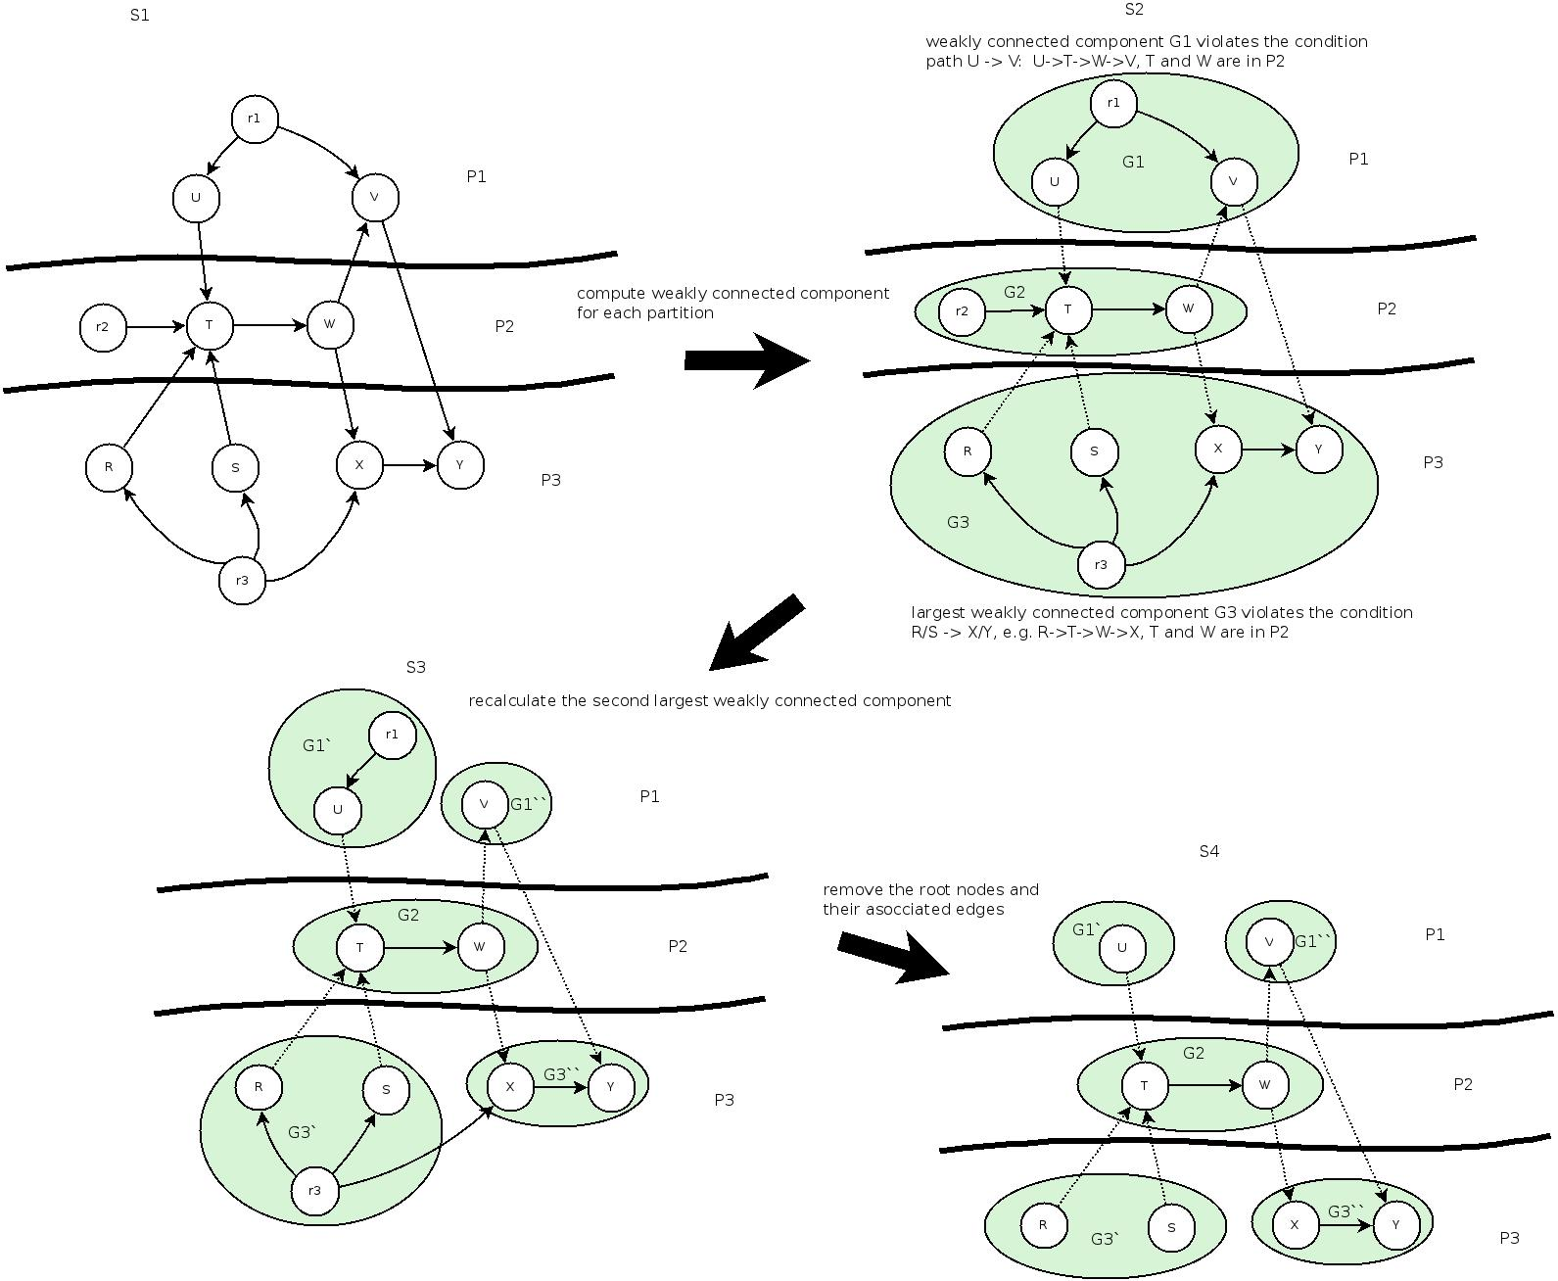

Form largest weakly-connected subgraphs (PWDGNode)

The algorithm for forming PWDG node came from Kopp.
Implementation follows the major algorithm with some modification.
Code: org.bpel4chor.splitprocess.pwdg.PWDGNodeConstructor.formNodes()

Email Archive:
From: "Oliver Kopp" <oliver.kopp@iaas.uni-stuttgart.de>
To: "daojun cui" <daojun.cui@gmail.com>
Cc: "Sebastian Wagner" <sebastian.wagner@iaas.uni-stuttgart.de>
Subject: Algorithmus für Weakly Connected Components with constraint satisfaction
Date: Tue, 22 Nov 2011 21:46:00 +0100
Idea:
"Move" nodes from set "ToCheck" to subgraphs (PWDG node)

//define
toCheck :Set of WDG Nodes
q :Queue of WDG Nodes
n :PWDG Node
all :Set of PWDG Nodes
root :root wdg node in the participant

for all participant do

toCheck <- wdg nodes of participant

// Start with root node
q <-

// put nodes into subgraphs (PWDGNode)
while |q|>=0 do
top <- dequeue(q)
n <- new PWDG Node with name(participant)
all <-
n.add(top)
for all WDG Node w in adjacentTarget(top) do
// add recursively to partition if no constraints is violated
addToPWDGNode(top, w)
end for
end while
end for

// p: parent wdg node , w child wdg node
function addToPWDGNode(p, w) {
// check for constraint violation

// node already placed in another PWDG node
If w is not in toCheck
return;

// same partition?
If participant(w) != participant
return;

// is there a path from p to n via another partition?
if pathViaOtherPartition(p,w)
// this node has to be processed as new root node next
queue.add(w);
return;
end if

// move nodes from “toCheck” to pwdg node n
n.add(w);
toCheck.remove(w);

// recursively add the successors of w into the pwdgNode
for all succesor c of w do
addToPWDGNode (w,c);
}

Some thinking about pathViaOtherPartition(p, n).
=>Our question is whether there is a path from p to n, that crosses via other partition.

=>It relates to the classic problem, Graph Algorithm To Find All Connections Between Two Arbitrary Vertices .
=>We alter the solution for all-vertices-all-paths for our question.
=>The only modification is that once we have found a path from p to n, test it right the way, if it crosses over partitions, then the procedure ends with pathViaOtherPartition(p,n)==true. If all the paths are tested, and none of them corsses over, then the procedure ends with pathViaOtherPartition(p,n)==false.

PartnerLink Specification for Invoking- and Invoked-Partition
Category | Name | Multiplicity
PartnerLink | invokingPartitionName  +invokedPartitionName  +'PL' | One for each pair of invoking- and invoked-partition
PartnerLinkType | invokingPartitionName  +invokedPartitionName  +'PLT' | One for each pair of invoking- and invoked-partition
Role | invokingPartitionName  +invokedPartitionName  +'ROLE' | One for each pair of invoking- and invoked-partition
PortType | invokingPartitionName  +invokedPartitionName  +'PT' | One for each pair of invoking- and invoked-partition
Operation | invokingPartitionName  +invokedPartitionName  +varName  +id(n)  +'OP' | One for each pair of invoking- and invoked-Local Resolver and Receiving Flow
Input | invokingPartitionName  +invokedPartitionName  +varName  +id(n)  +'Input' | One for each Operation
Message | InvokingPartitionName  +invokedPartitionName  +varName  +[id(node)]  +'[SQ,MQ]Message' | Single query set use SQ, it can be reused, for  Multiple query sets use MQ, it can not be reused. Each node a message

Message Specification for Invoke in LR and Receive in RF
Category | Specification
Message for single query set(SQ) | Name=  invokingPartitionName  +invokedPartitionName  +varName  +'SQMessage'  (it can be reused for all messages between the node n_{i} in its partition p_{n} and the reader partition p_{r}, as long as they have only single query set)
Message for multiple query sets(MQ) | Name=  invokingPartitionName  +invokedPartitionName  +varName  +id(node)  +'MQMessage'  (it is unique, one for each node n_{i} that have multiple query set)
Part 'status' | name='status' type='boolean' for SQ  name ='status'+id(Qsn) type='boolean' for MQ  Note: There can be multiple status parts, dependent on how many queries are there.
Part 'data' | name='data' type='any', messageType of the current variable X
Part 'correlation' | name='correlation' type='string'
Examples | <!-- Message for Single QuerySet -->  <message name=”pnprVarNameSQmessage”>  <part name=”status” type=”boolean”>  <part name=”data” type=”any”>  <part name=”correlation” type=”string”>  </message>  <!-- Message for Multiple QuerySet -->  <message name=”pnprVarName6lkMQmessage”>  <part name=”statusQs1” type=”boolean”>  <part name=”statusQs2” type=”boolean”>  <part name=”data” type=”any”>  <part name=”correlation” type=”string”>  </message>
Special Case  The PWDG node and the reader are in same partition, and there multiple query sets | <!-- Same partition muliple query sets -->  <message name=”prprVarName6lkMQmessage”>  <part name=”statusQs1” type=”boolean”>  <part name=”statusQs2” type=”boolean”>  <part name=”dataPart1OfVar” type=”...”>  <part name=”dataPart2OfVar” type=”...”>  </message>

Variable Initialization respecting the preset message specification
Variable for the Invoke activity in Local Resolver will be of MessageType(with two parts, “status” and “data”)
Its Initialization will be using the following pattern
<variable name=”LRVarName” messageType=”tns:pnprVarNameSQmessage”>
<variable name=”x” messageType=....>// variable of non-split-process
<assign>
<copy>
<from variable=”x” />
<to variable=”LRVarName” part=”data” />
</copy>
</assign>

Creating prerequisites of LR and RF
Main logic for creating prerequisites of local resolver and receiving flow
Function CREATE-PREREQUISITES(PWDG pwdg, Query-Writer-Tuple Q(a, x) , Map id, Map id_{n})
// id is the map associating unique name to querySet
// id_{n} is the map associating unique name to pwdg node n
a is global member
x is global member
p_{r}: = participant of a
defn: WSDL Definition of p_{r}

For all node n in pwdg do
if p_{n} == p_{r} then
continue
// different partition
Q_{s} = Q_{s}(n, a, x)
if |Q_{s}|==0 then
continue

Create-Prerequisite-Message
Create-Prerequisite-PortType-Operation
Create-Prerequisite-PartnerLinkType
Create-Prerequisite-ParnterLink
End For

Function Create-Prerequisite-Message
Function Create-Prerequisite-Message(PWDGNode n, Query-Writer-Tuple Q_{s}(n, a, x) , Map id, Map id_{n})
if |Q_{s}|=1 then
if !existSQMsgBetween(p_{n}, p_{r}) then
Create-Prerequisite-SQ-Message(p_{n}, p_{r})
end if
else if |Q|>1 then
Create-Prerequisite-MQ-Message(p_{n}, p_{r}, Q_{s}, id, id_{n}(n))
end if

Function Create-Prerequisite-PortType-Operation
Function Create-Prerequisite-PortType-Operation(Participant p_{n}, Participant p_{r}, PWDGNode n, QueryWriterSet Q, Map id_{n})
// create portType now
if !existPortTypeFor(p_{n}, p_{r}) then
Create-Prerequisite-PortType(p_{n}, p_{r})
end if

pt = getPortTypeFor(p_{n}, p_{r}, defn)
msg = getMessageFor(p_{n}, p_{r}, n, Q, id_{n}, defn)
Create-Prerequisite-Operation(p_{n}, p_{r}, msg, id_{n}(n), pt)

Function Create-Prerequisite-PartnerLinkType
Function Create-Prerequisite-PartnerLinkType
// create partnerLinkType
if !existPartnerLinkTypeFor(p_{n}, p_{r}) then
plt = Create-Prerequisite-PartnerLinkType(p_{n}, p_{r})
role = Create-Prerequisite-Role(p_{n}, p_{r})
pt = getPortTypeFor(p_{n}, p_{r}, defn)
role.setPortType(pt)
plt.getRole().add(role)
defn.add(plt)
enf if

Function Create-Prerequisite-PartnerLink
// create partnerLink
if !existPartnerLinkFor(p_{n}, p_{r}) then
Create-Prerequisite-ParnterLink(p_{n}, p_{r})
end if

Functions for creating prerequisites of local resolver and receiving flow
Function Create-Prerequisite-SQ-Message
Function Create-Prerequisite-MQ-Message
Function Create-Prerequisite-Operation
Function Create-Prerequisite-PortType
Function Create-Prerequisite-Role
Function Create-Prerequisite-PartnerLinkType
Function Create-Prerequisite-ParnterLink
Function existSQMsgBetween
Function existPortTypeFor
Function existPartnerLinkTypeFor
Function existPartnerLinkFor

Creating Local Resolver
The implementation of Local Resolver will do some adjustment to the algorithm in the paper, the concepts of the implementation are as follows:
The local resolver handles 4 Cases:
- |Q_{s}| =1, p_{n} == p_{r}
- |Q_{s}| =1, p_{n} != p_{r}
- |Q_{s}| >1, p_{n} == p_{r}
- |Q_{s}| >1, p_{n} != p_{r}

Case 1 - |Q_{s}| =1, p_{n} == p_{r}
Tuple set of Query Set and Writer Set contain only single tuple, node and reader are in the same participant.
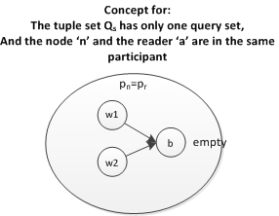

Case 2 - |Q_{s}| =1, p_{n} != p_{r}
Tuple set of Query Set and Writer Set contain only single tuple, node and reader are in different participants.
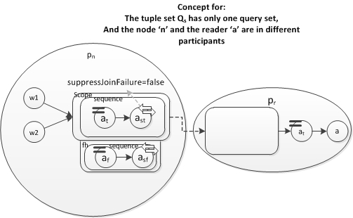

Case 3 - |Q_{s}| >1, p_{n} == p_{r}
Tuple set of Query Set and Writer Set contain more than one tuple, node and reader are in the same participant.
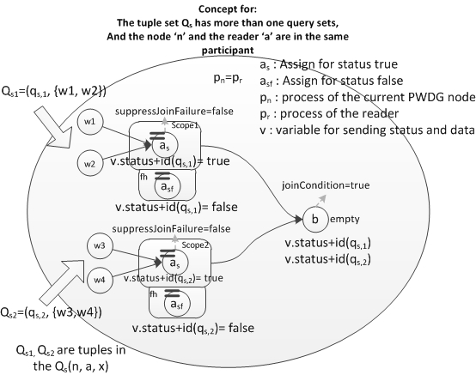

Case 4 - |Q_{s}| >1, p_{n} != p_{r}
Tuple set of Query Set and Writer Set contain more than one tuple, node and reader are in different participants.
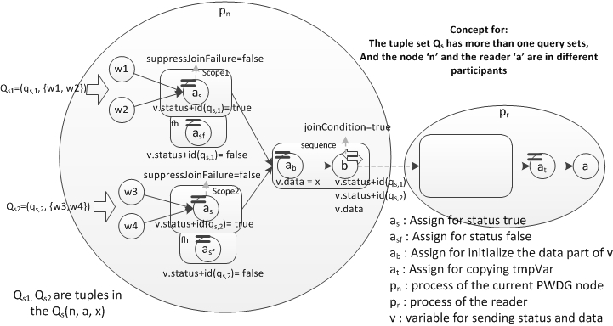

The revisited version of the algorithm for creating local resolver
The algorithm is made more expanded, but logically clearer.
Procedure CREATE-LOCAL-RESOLVER-MULTIPLE-WRITERS(Node n, Activity a, Vriable x)

Q = Q_{sp}(n, a, x)

if |Q|=1 then let Q={q_{s}}// single query set
if p_{n} = p_{r} then
Add b=new empty, v=new variable, v.name=id_{n}(n), t=v.name
else //p_{n}!=p_{r}
create PartnerLink/Variable/Message
b = CREATE-SENDING-BLOCK(name(x))
end if
for alldo
if type(w)=loop then
// todo
else
Add link l=(w,b,true())
end if
end for
else // more than one query set
v = new variable, v.name=id_{n}(n)
m = get pre-created MQMessage from Definition of p_{r}
v.messageType = m, t=v.name
if p_{n} = p_{r} then
Add b=new empty,
else //p_{n}!=p_{r}
add b=new invoke,
b.inputVariable=v, b.toPart=(“data”,x), b.joinCondition=”true()”
end if
for all do
s = CREATE-ASSIGN-SCOPE(t,q_{s})
Add link l = (s, b, true())
end for
end if
*yellow highlighting texts are functions*
n: pwdg node
a: Reader Activity
x: Variable that reader depends on
Q_{sp}(n, a, x): partition filtered Q_{s}(a,x), only the writers in pwdg node n
p_{n}: Participant where the node n resides
p_{r}: Participant where the reader activity resides
b: depends on position of the reader and PWDG node , a empty, a scope (sending block), or an invoke.
id_{n}(n): a unique string for node n
v: new Variable, v.name=id_{n}(n)=unique string for node n.
w: writer activity in query-writer-set q_{s}
l: link
t: String
s: scope

Activity Naming Convention for Sending Block in LR (Case 2 |Q_{s}| =1, p_{n} != p_{r})
Category | Specification
Scope | Name='LR' + varName + idn(node) + 'Scope'
Sequence | Name='LR' + varName + idn(node) + 'Sequence'
Sequence(FH) | Name='LR' + varName + idn(node) + 'SequenceFH'
Invoke | Name='Send' + varName + idn(node)
Invoke(FH) | Name='Send' + varNameFH + idn(node)
Assign | Name='Assign' + varName + idn(node)
Assign(FH) | Name='Assign' + varName + idn(node) + 'FH'

Variable Naming Convention for Invoke in Sending Block in LR (Case 2 |Q_{s}| =1, p_{n} != p_{r})
Variable Category | Specification
InputVariable | Name = id_{n}(node)
FaultHandler InputVariable | Name = id_{n}(node)+”FH”

Creating Sending Block for Local Resolver
The creation of the sending block is using the same concept as the one in the control link fragmentation, in which the variable is initialized before the
Artifacts to create:
- A new Scope
- A new Variable for sending true, a new Variable for sending false
- A new 'Sequence' for sending true, it contains an 'Assign' activity and an 'Invoke' activity.
- A new 'Sequence' for sending false, it contains an 'Assign' activity and an 'Invoke' activity.
Configurations needed:
- Setup the messageType of the variables
  - For the message sending true and data, the data part is set to the variable in local process that has the same name of the x.
  - For the message sending false, only the status part is needed to be set.
- Setup the operation, portType, partnerLink of the invoke activities.
- Set 'suppressJoinFailure=false' in the 'Invoke' activity sending true

Activity Naming Convention (Case 3 |Q_{s}| >1, p_{n} == p_{r})
Category | Specification
Empty | Name=idn(node)+'Empty'

Variable Naming Convention (Case 3 |Q_{s}| >1, p_{n} == p_{r} and Case 4 |Q_{s}|>1, p_{n}!=p_{r})
Category | Specification
InputVar (variable for collecting queried part statuses, data, and correlation, referred by Invoke) | Name=idn(node)

Activity Naming Convention for Creating Assign Scope in LR (Case 3 and 4)
Category | Specification
Sequence | Name= idn(node)+'Sequence'
Invoke(in the Sequence) | Name='Send' + varName + idn(node)
Assign(in the Sequence) | Name='Assign'+varName+idn(node)
Scope(assign scope) | Name='AssignScope' + varName + id(q_{s})
Assign(in the AssignScope) | Name='Assign' + varName + id(q_{s})
Assign(FH in the AssignScope) | Name='Assign' + varName + id(q_{s}) + 'FH'
Note: The varName is the name of the current variable that is being handled.

What is needed for implementing the algorithm
- Get Q_{s}(n, a, x) : org.bpel4chor.splitprocess.dataflowanalysis.QueryWriterSet
- |Q| size of Q_{s}(n, a, x): QueryWriterSet.size()
- Get participant of the PWDG node: PartitionSpec.getParticipant(node.getActivity())
- Get participant of the current activity a: PartitionSpec.getParticipant(a)
- Get the map that associates a unique name to the query set, id(q)
- Get the map that associates a unique name to the node, id_{n}(node)
- Create PartnerLink, PartnerLinkType, Role, PortType, Operation, Message
- Create sending block
- Create assign scope

Id – Unique String for query set
Query Set | Id
{.a, .b, .c} | id({.a, .b, .c})='xxx'(the id string consists number and character)
Note: the empty string “” in the query set implies that the whole variable is queried

Id – Unique String for PWDG node
PWDG Node | Id
n₁=(s₁,{A, B, C}) | id(n₁)='xxx'(the id string consists of number and character)

Initialization of the inputVariable for the invoke
- For the Sending Block the data part of the inputVariable for the invoke activity must be initialized with the given variable the so called variable 'x', which is being read by the reader.
- For the Assign Scope, the data part of the inputVariable for the invoke activity must be initialized with the given variable 'x' too.
But it must be noticed that the given variable 'x' is from the main process. The corresponding one must be found in the local fragment process and be assigned in the data part of the inputVariable for the invoke activity that sends the data and status.

Issue to map the variable data into the sending message's data part

Creating Receiving Flow

Create-Receiving-Flow handles 5 Cases
- p_{n}==p_{r}, |Q|==1, |B|==1, where B={b} is the writer set in the PWDG node
- p_{n}==p_{r}, |Q|==1, |B|!=1
- p_{n}==p_{r}, |Q|!=1
- p_{n}!=p_{r}, |Q|==1
- p_{n}!=p_{r}, |Q|!=1

Concept for Process-Node
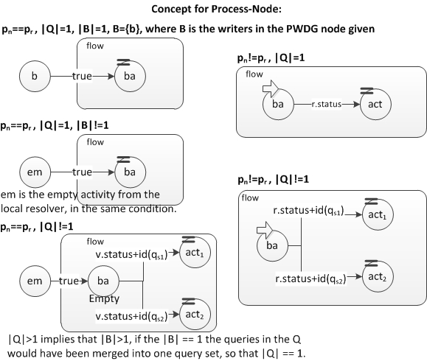

Activity Naming Convention in Create-Receiving-Flow
Category | Specification
Flow | Name=varName + 'RFFlow'
Assign (copy tmpVar to var) | Name='AssignTmp'+readVarName+'4'+readerActName

Variable Naming Convention for Receiving Flow
Category | Specification
Variable(tmpVar for the whole receiving flow) | Name='tmp'+varName+'4'+readerActName

Activity Naming Convention in Same participant in Process-Node
Category | Specification
Assign (case p_{n}==p_{r}, |Q|==1, |B|==1or |B|!=1) | Name='Assign'+id(node)
Empty (case p_{n}==p_{r}, |Q|!=1) | Name='RF'+id(node)+'Empty'
Assign (case p_{n}==p_{r}, |Q|!=1) | Name='Assign'+id(node)+id(qs_{n})

Activity Naming Convention in different participant in Process-Node
Category | Specification
Receive (case p_{n}!=p_{r}, |Q|==1) | Name='Receive'+id(node)
Assign (case p_{n}!=p_{r}, |Q|==1) | Name='Assign'+id(node)
Receive (case p_{n}!=p_{r}, |Q|!=1) | Name='Receive'+id(node)
Assign (case p_{n}!=p_{r}, |Q|!=1) | Name='Assign'+id(node)+id(qs_{n})

Variable Naming Convention in different Participant in Process-Node
Category | Specification
InputVariable (for the receive) | Name=id(node)

Output of BPEL4Chor Artifacts
In general, the output of ProcessSplitter will be created into the output directory, the output includes PBDs, WSDLs, Topology, Grounding.
Note:
- The output directory is should be given by the invoker of ProcessSplitter, if not the default output directory that is stored in the constant SplitProcessConstants.DEFAULT_SPLITTING_OUTPUT_DIR(c:\tmp\bpel4chor) will be used.
- Besides the contents of the output directory will be compressed into a zip file, which is named with the following naming convention: Non-Split-ProcessName+'Choreography'+CurrentTimeInMilliseconds.zip

Collecting BPEL4Chor Artifacts

Process Fragmentation
In the stage of Process Fragmentation,
For <topology>
- <participantTypes> can be created, since we now know about the BPEL fragment processes, for each <participantType> we can get the information for attribute participantBehaviorDescription.
- <participants> can be created, since we already know the participantType, for each fragment process there is a <participant>. We can get information for the attribute name and type, but the attribute selects will not be available until next stage “Control Link Fragmentation”.
- <messageLinks> will not be available until next stage “Control Link Fragmentation”.
For <grounding>, so far, there is nothing to collect, because the handling of the message link comes in next stages “Control Link Fragmentation” and “Data Dependency Fragmentation”.

Control Link Fragmentation
In the stage Control Link Fragmentation, we collecting Information for message link in BPEL4Chor artifact <topology> and <grounding>.

For each split link, there is a new <messageLink> created in both the <topology> and <grounding>. Note that only a part of the attributes in each of the new message links are known in this procedure. The attributes such as ‘name’ and ‘sender’ are related to the sending block, therefore are available. The rest of the information for the message links will be filled in the procedure CREATE-RECEIVING-BLOCK.

Data Dependency Fragmentation
The new <messageLink> for <topology> and <grounding> are collected in the createLocalResolver and createReceivingFlow under the condition that the PWDG node and the reader are not in the same participant.

Specification for BPEL4Chor Artifacts
Participant Behavior Description (PBD)
Participant Behavior Description Attribute | Specification | Collect
partnerLink, portType, operation | forbid | -
“wsu:id” type=”xsd:id” | onMessage branch, invoke, receive | Print out by BPEL4ChorWriter
“messageExchange” | each pair of recive and reply (synchronous operation) | Collected by ProcessFragmenter
correlationSet | use “NCName” | Collected by ProcessFragmenter

Topology
Element | Attribute | Specification | Source of Information | Sub-Elements
topology | name | nonSplitProcessName+'Topology' | Initialization | participantTypes(+),  participants(+),  messageLinks(+)
topology | targetNamespace | TOPOLOGY_TARGET_NAMESPACE | Initialization | participantTypes(+),  participants(+),  messageLinks(+)
topology | namespaces | Collect all namespaces from all QNames | Initialization | participantTypes(+),  participants(+),  messageLinks(+)
participantTypes |  |  | Initialization | participantType(+)
participantType | name | participantProcessName+'Type' | Process Fragmentation
participantType | participantBehaviorDescription | QName, Namespace of the nonSplitProcess + particpiantName | Process Fragmentation
participantType | processLanguage(?) | anyURI | Process Fragmentation
participants |  |  | Initialization | participant(+), participantSet(*)
participant | name | fragment process name | Process Fragmentation
participant | type | the participantType Name | Process Fragmentation
participant | selects(?) | the invoked fragment process name | Control Link – & Data Dependency Fragmentation
participant | scope(?) | QName | ??
messageLinks |  |  | Initialization | messageLink(+)
messageLink | name | messageName+'Link'(default messageName) | One message link for each split control link and one for each message that is generated in data dependency fragmentation
messageLink | sender | senders | (invoking participant name) | (participants name)
messageLink | sendActivity | Invoking Activity Name = 'Send'+varName+idn(node)
messageLink | receiver | invoked participant name
messageLink | receiveActivity | receiving activity name = 'Receive'+idn(node)
messageLink | messageName | message name

Grounding
Element | Attribute | Specification | Source of Information | Sub-Elements
grounding | topology | Qname, {NS}:nonSplitProcessName+'Grounding' | Initialization | messageLinks(+),  participantRefs(+),  properties(+)
grounding | targetNamespace | GOURNDING_TARGET_NAMESPACE | Initialization | messageLinks(+),  participantRefs(+),  properties(+)
grounding | namespaces | Collect all namespaces from QNames | Initialization | messageLinks(+),  participantRefs(+),  properties(+)
messageLinks |  |  | Initialization | messageLink(+)
messageLink | name | Same as the one in topology | Control Link -, Data Dependency Fragmentation
messageLink | portType | portType name | Control Link -, Data Dependency Fragmentation
messageLink | operation | operation name | Control Link -, Data Dependency Fragmentation
participantRefs |  |  | Initialization | participantRef(+)
participantRef | name | NCName | Control Link -, Data Dependency Fragmentation
participantRef | WSDLproperty | QName | Control Link -, Data Dependency Fragmentation
properties |  |  | Initialization | property(+)
property | name | NCName | Control Link -, Data Dependency Fragmentation
property | WSDLproperty | QName | Control Link -, Data Dependency Fragmentation
* Recall that we use only one global correlation set which contains only one property, then we collect the WSDL property into the grounding at the very beginning of the initialization of the splitting procedure.

Participant Behavior Description (PBD) Writer
We transform the BPEL Process into an abstract process profile PBD. In the transform process, the BPELWriter is used. Since the PBD forbids the existence of partnerLink, portType, and operation, we must override the xxx2xml methods in the BPELWriter so that the output of partnerLink, portType, and operation are by-passed.

Writing Out BPEL4Chor Artifacts
The artifacts that are generated while splitting process will be put to the output directory, which is pre-set in the run-time data.
Logic for output BPEL4Chor Artifacts
Source:
org.bpel4chor.utils.BPEL4ChorWriter.writeBPEL4Chor(Map<String, Process>, Map<String, Definition>, Topology, Grounding, String, String, String)
See also in:
org.bpel4chor.splitprocess.ProcessSplitter.split()
org.bpel4chor.utils.BPEL4ChorWriter.writeBPEL4Chor(Map<String, Process>, Map<String, Definition>, Topology, Grounding, String, String, String)
called by org.bpel4chor.splitprocess.ProcessSplitter.split()
called by org.bpel4chor.splitprocess.cli.SplitProcessMainCmd.run(String[])
called by org.bpel4chor.splitprocess.cli.SplitProcessMainCmd.main(String[])

Compressing output files into one zip file
The files in the output directory will be put into one zip file, which is placed in the destine directory.
Logic for creating zip file
Source:
org.bpel4chor.utils.ZipUtil.zip(String, String, String)
See also:
org.bpel4chor.utils.BPEL4ChorWriter.writeBPEL4Chor()
org.bpel4chor.utils.ZipUtil.zip(String, String, String)
called by org.bpel4chor.utils.BPEL4ChorWriter.writeBPEL4Chor()

Decompressing the zip file
The ZipUtil provides also the method that decompresses the zip file for the BPEL4Chor output.
Logic for extracting zip file
Source:
org.bpel4chor.utils.ZipUtil.unizp(String, String)

The unzip method accept the zip file path and extracts the zip file entries into the pre-given destine directory.

Correlation Set

Specification of Correlation Set
As mentioned in previous section we use only one correlation set in the main BPEL process. Due to the complexity of correlation. The correlation set we used is fixed.
Specification of Correlation Set in main BPEL process
<bpel:correlationSets>
<!-- we use only one property, the name of the property is also fixed -->
<bpel:correlationSet name="CorrelationSet" properties="tns:correlProperty"/>
</bpel:correlationSets>

Specification of Correlation in main WSDL definition
<vprop:property name="correlProperty" type="xsd:string" />

<!-- propertyAlias that points the property to the corresponding message part -->
<vprop:propertyAlias propertyName="tns:correlProperty" messageType="tns:orderRequest" part="correlation" />
<vprop:propertyAlias propertyName="tns:correlProperty" messageType="tns:orderResponse" part="correlation" />

Request Message of the main process must contain one correlation part
<message name="orderRequest">
<part name="acountNumber" type="xsd:string"/>
<part name="status" type="xsd:string"/>
<part name="orderTotalPrice" type="xsd:int"/>
<part name="numDeliveries" type="xsd:int"/>
<part name="correlation" type="xsd:string"/>
</message>

<message name="orderResponse">
<part name="text" type="xsd:string" />
<part name="correlation" type="xsd:string" />
</message>

Handling Correlation Set in Process Fragmentation
Concept of handling the correlation set and the property
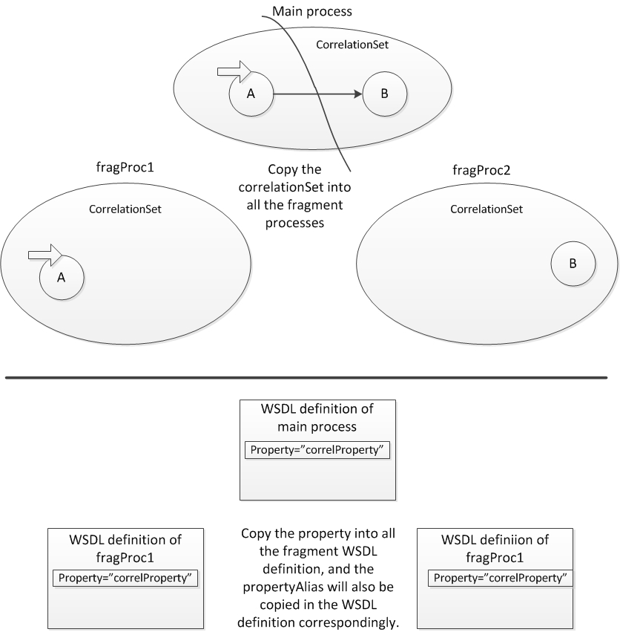

Handling Correlation Set in Control Link Fragmentation
The concept of handling the correlation set in the control link fragmentation phase
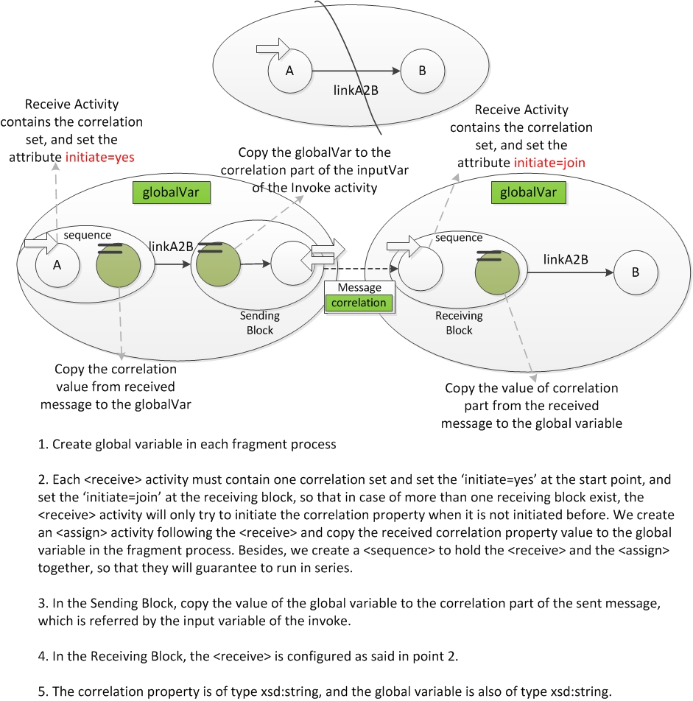

Handling Correlation Set in Data Dependency Fragmentation
Concept of handling Correlation in the data dependency fragmentation phase
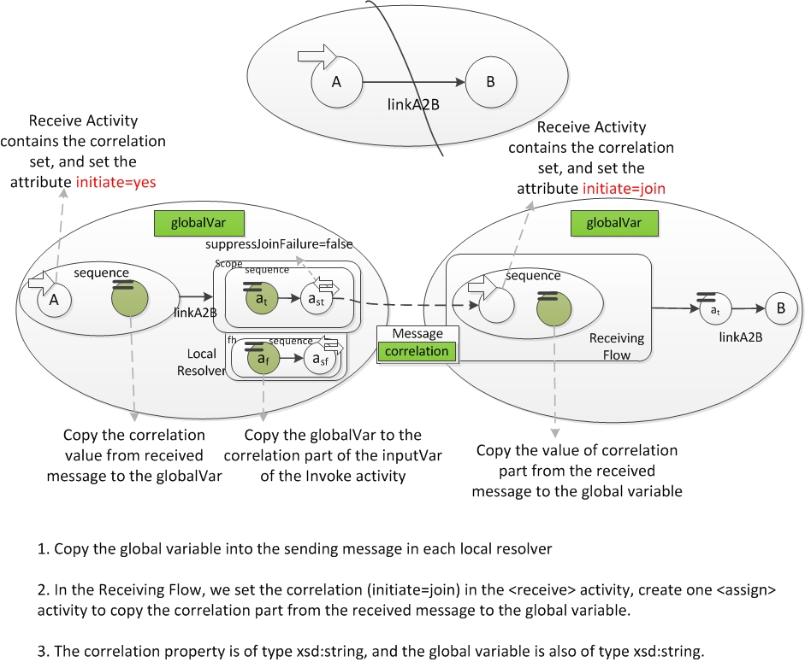

Places Related To The Correlation Set
Relevance | Location | Phase
The correlation part in Control Link Message | FragmentFactory.createControlLinkMessage() | Control Link
Add propertyAlias because of the message | ControlLinkBlockBuilder.createPrerequisites() | Control Link
Assign Global Variable | ControlLinkBlockBuilder.createSendingBlock() | Control Link
Set up correlation in the <receive> activity | ControlLinkBlockBuilder.createReceivingBlock() | Control Link
Add correlation part in the Data Dependency Message | DataDependencyHelper.  - createPrerequisiteSQMessage()  - createPrerequisiteMQMessage() | Data Dependency
Add propertyAlias because of the message | DataDependencyHelper.createPrerequisites() | Data Dependency
Assign Global Variable to message part correlation (in case of same partition) | DataDependencyFragmenter.  - createLocalResolver()  - createAssignVarTrueAndData4SendingBlock()  - createAssignVarFalse4SendingBlock() | Data Dependency
Assign Global Variable to message part correlation (in case of different partition) | DataDependencyFragmenter.  - createLocalResolver()  - createSequence4MQAndDiffPartition() | Data Dependency
Set correlation in the <receive> activity, and create one <assign> to copy global var, and create one <sequence> to encapsulate both of the activities. | DataDependencyFragmenter.  - processNode()  - processNodeInDiffParticipant() | Data Dependency
Wrap initial <receive> activity and one <assign> activity into a <sequence> activity | DataDependencyFragmenter  - splitDataDependency()  - wrapInitialReceive() | Data Dependency

Project Metrics
Project Metrics for the org.bpel4chor.splitProcess
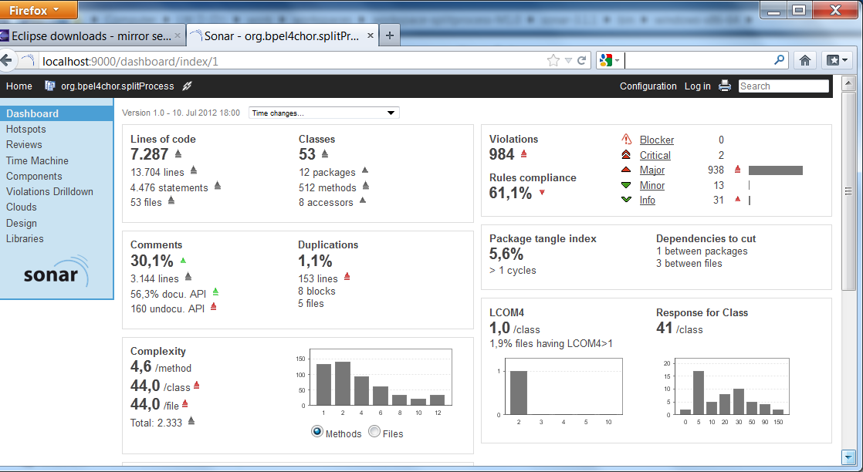

Splitting Process Test

Project Specification
Project parameter | Specification
Project Name | org.bpel4chor.splitprocess.test
Project Type | Test Project
Description | This project provides Unit-Tests for org.bpel4chor.splitprocess
Ref. Libraries | Junit 4, Log4j
Ref. Projects | org.bpel4chor.splitprocess

BPEL Projects for Testing
The test BPEL projects find themselves under the directory [WORKSPACE]/org.bpel4chor.splitProcess.test/files/

Prerequisites for Opening the BPEL Projects
- Eclipse BPEL Designer (Tip: it is better to install a new Eclipse with the BPEL designer installed, and import the BPEL projects into another workspace. So that is will no interfere with the source code in the main stream.)
- Apache ODE (Tip: it is optional, it will be ok, if you just want to run the JUnit Test. Though, there will be some warning in the project explorer, since Apache ODE was assigned as the target run-time server, as the BPEL projects were created.)

Correlation Set in The Test BPEL process
The correlation set is manually added in the BPEL process. The correlation set locates in two places: (1) The BPEL Process, and (2) the corresponding WSDL definition.
It looks like:
Example in the BPEL process OrderInfoSimple1
<bpel:correlationSets>
<bpel:correlationSet name="CorrelationSet"
properties="tns:correlProperty">
</bpel:correlationSet>
</bpel:correlationSets>

Test Partition Specification
The Test Partition Specification is always named Partition.xml and directly placed under the same directory where the BPEL process locates.
Note: the name of the partition file is not restricted, one can choose the file name whatever he wants.
Example of the Partition file for OrderInfoSimple1
<!-- OrderingProcessSimple1 partition specification -->
<partitionSpecification>
<participant name="participant1">
<activity path="/bpel:process/bpel:flow/bpel:receive[@name='ReceiveA']"/>
</participant>
<participant name="participant2">
<activity path="/bpel:process/bpel:flow/bpel:assign[@name='AssignB']"/>
</participant>
</partitionSpecification>

Project Metrics
The Project Metrics for org.bpel4chor.splitProcess.test
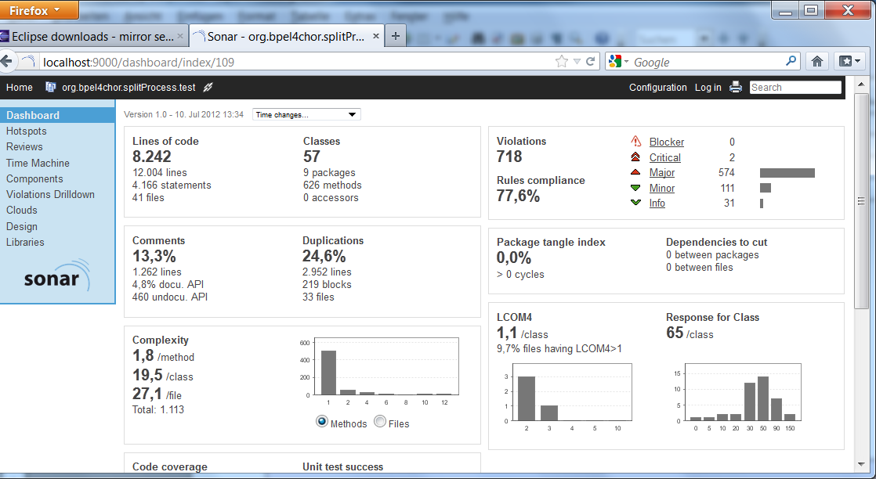

Khalaf Rania: Supporting Business Process Fragmentation While Maintaining Operational Semantics-A BPEL Perspective, 2008, Chapter 5.3, Defining a partition, Page 93 94 95.
Javier Fernandez: BPEL with Explicit Data Flow: Model, Editor, and Partitioning Tool, Diplomarbeit Nr. 2616
(a)a partition has at least one activity (b)a activity can only be assigned in one partition (c)each activity must be assigned to one partition.
The both functions are from Khalaf' Dissertation Page 108 and 109.
Javier Fernandez: BPEL with Explicit Data Flow: Model, Editor, and Partitioning Tool, Diplomarbeit Nr. 2616, 2007

